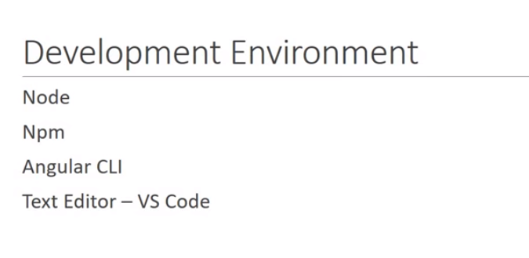

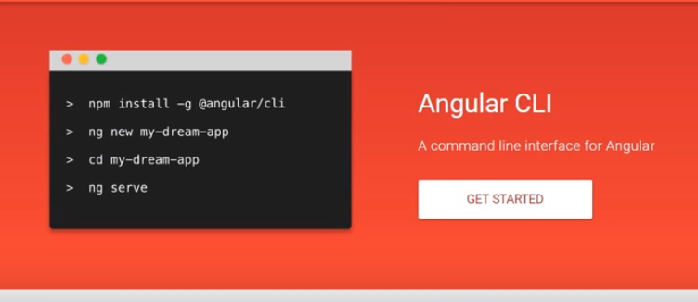

**Tutorial 1: Hello-world app**

1)To create project:-

Ng new hello-world

1. To start server

Cd hello-world

Ng serve

Browser:-- localhost:4200

NOTE: angular is just a collection of individual module.

Every angular application has at least one module and that is root module and by convention i.e AppModule

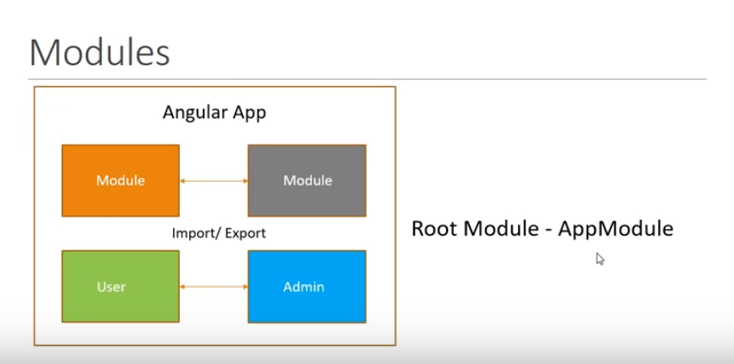

Each module is made of components and services.

Components control a portion of view on the browser and again component has atleast one root component and by convention this is called AppComponent And all other component nested inside main component

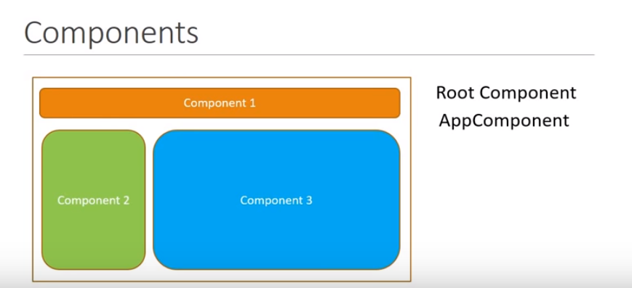

Each component has html template to see view and a class to contain the logic

NOTE: component represent different view in the browser

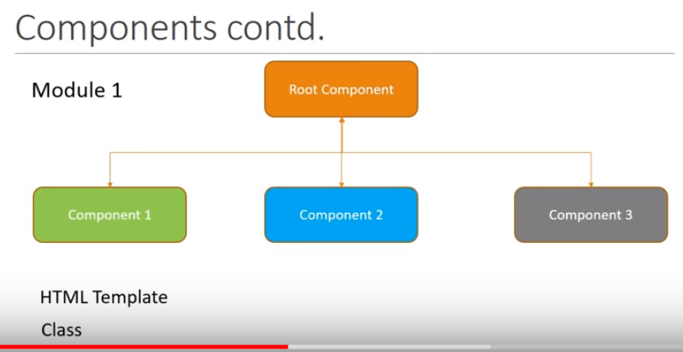

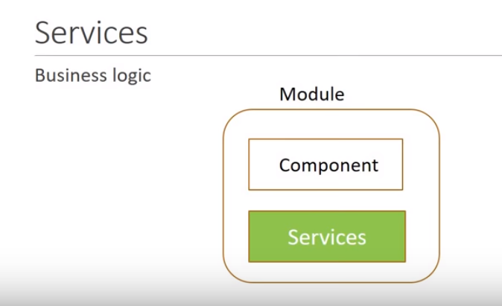

Service :- a class that contain business logic

NOTE: modules import and export code as when it is required

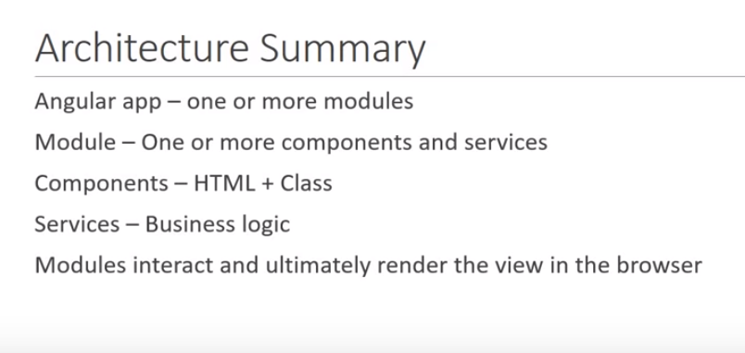

NOTE: in src folder/

main.ts file---- entry point for angular js

App.module.ts---------------------root module of application

App.component.ts---------------root component of application

App.component.html

Tutorial 2)

Detail looks of component

Component consist of three part:-

1. Template is view
2. Class( typescript which support view that contain logic)

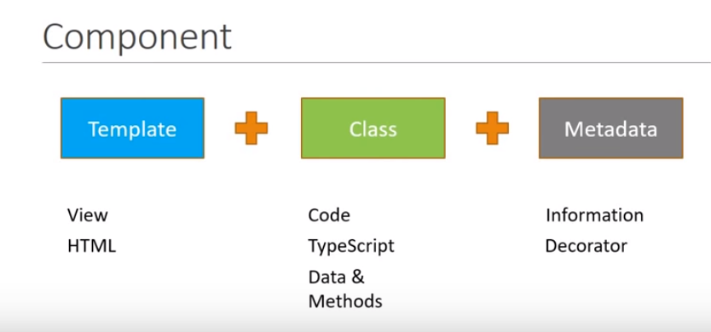

Component decorator is a function that attaches to class

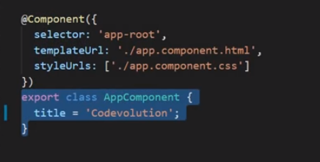

Selector is a custom data ie used to represent component

NOTE: angular renders the component when it come across app-root selector

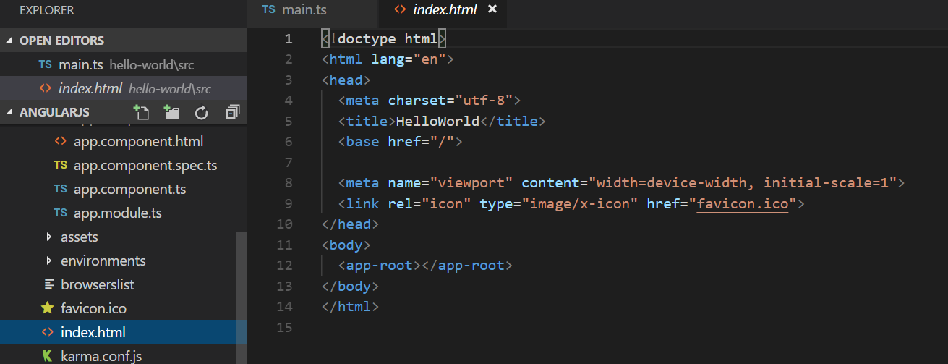

To create new component : ng g c test( ng generate component)

Note: if any new component is created it will add to app.module.ts

------declaration array will contain all the component used by array

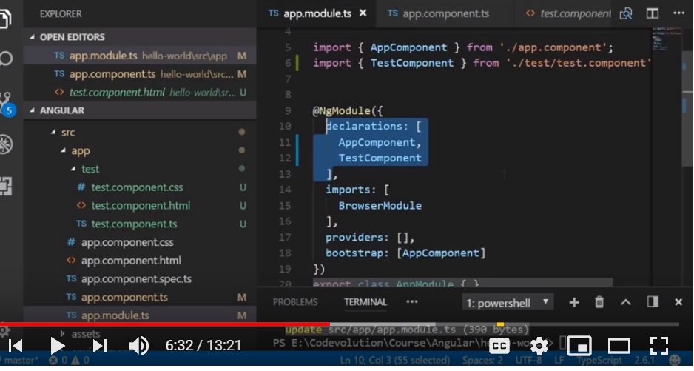

App-component is root component of html and all other component will fall under this component

There are three ways to specify selector for component:-

Custom tag, class or as a attribute

Tutorial 4

Inline template ( we can use back trace to specify multiple line)

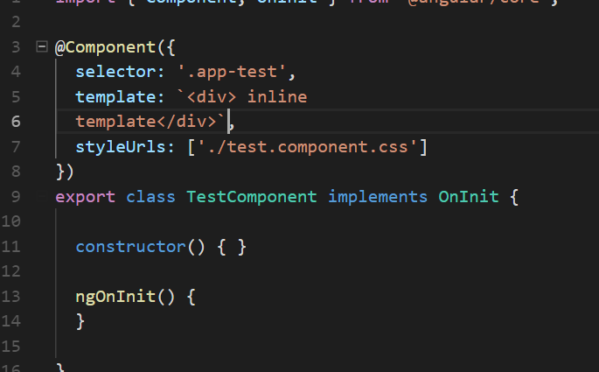

Tutorial 3:) Interpolation

Binding of name from class to template

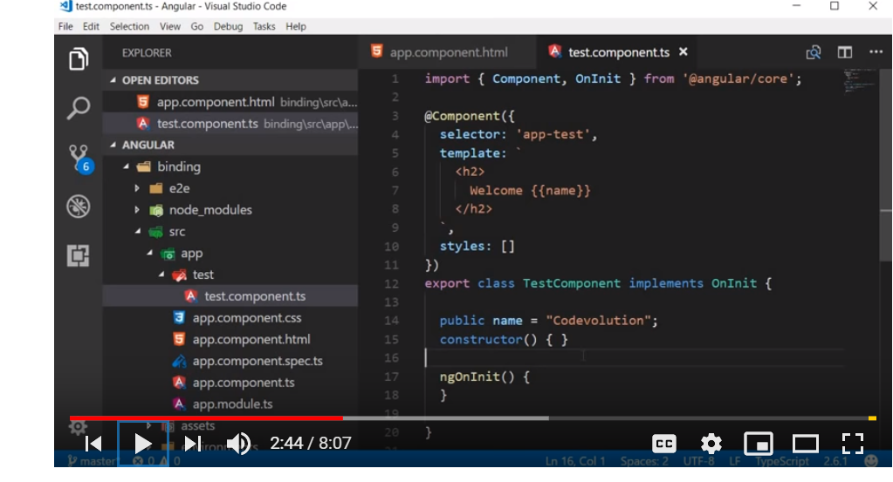

// can be done by using interpolation:-

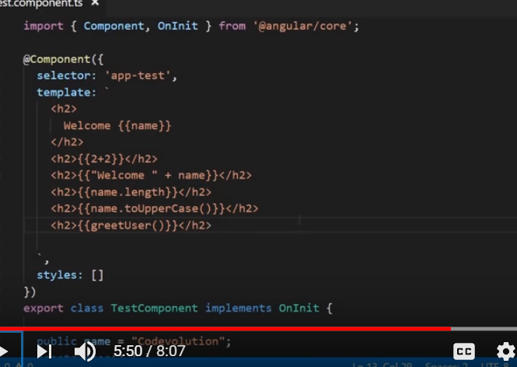

//output

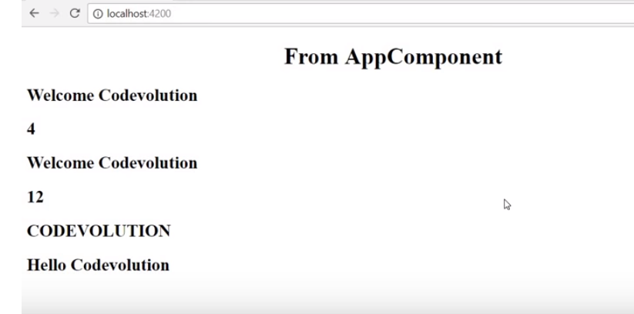

**Can't be done using interpolation**

**1)**assigning value to a variable is not possible

1. Access to global variable is not possible such as window( not aware of global javascript variable)

But we can bind it through a variable:-

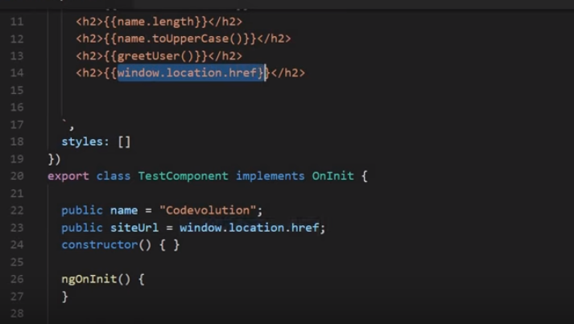

NOTE:

We can call method define in class from interpolation

**Tutorial -4( Property binding)**

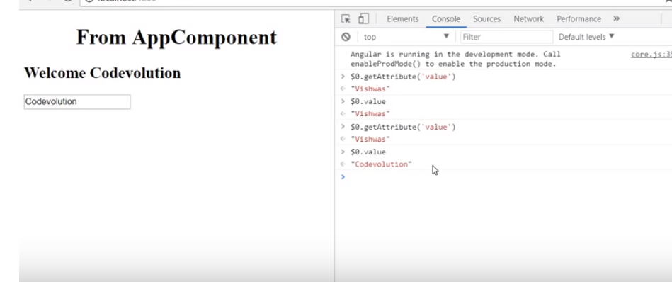

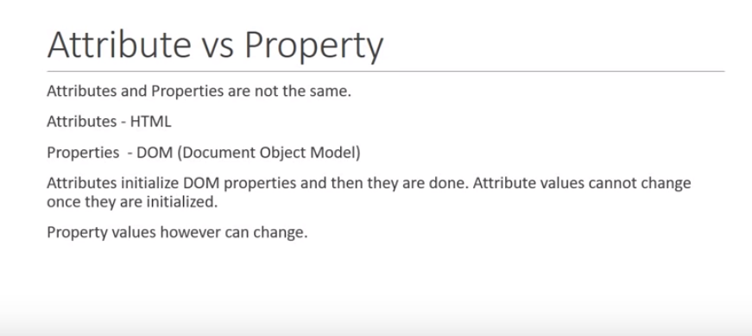

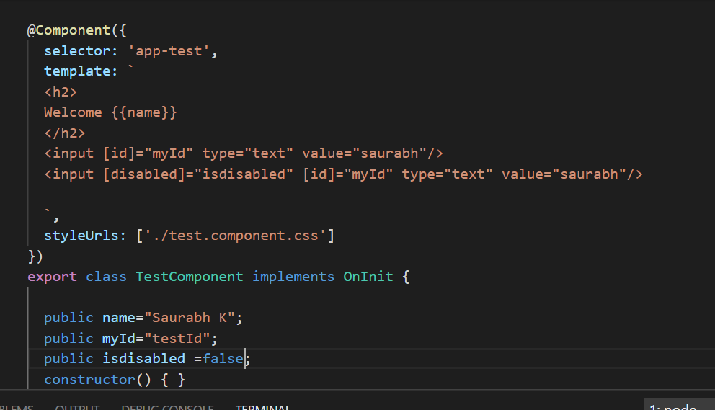

**Tutorial-5 ( class binding)**

**For applying multiple class use ng-class**

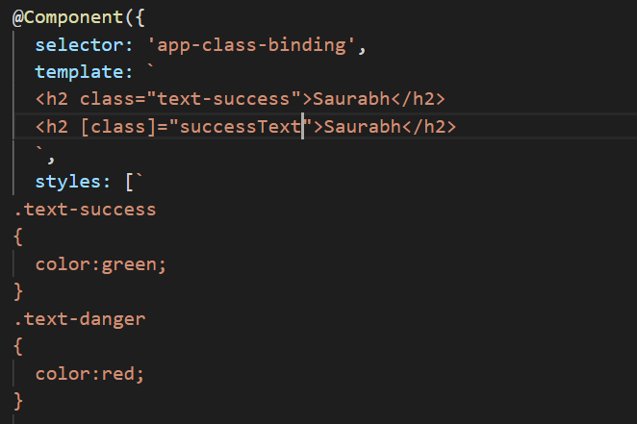

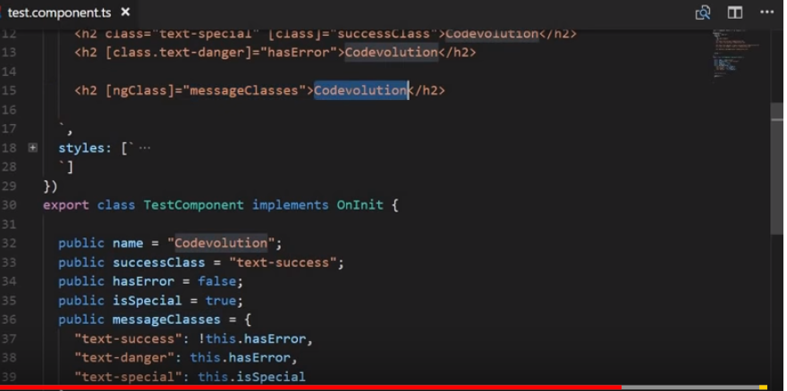

**Tutorial 6) style binding**

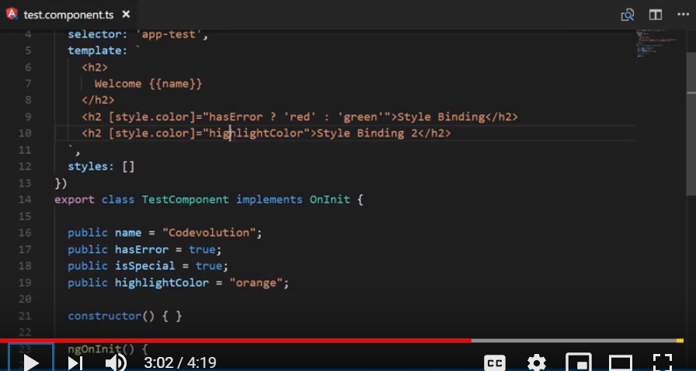

**To apply multiple style**

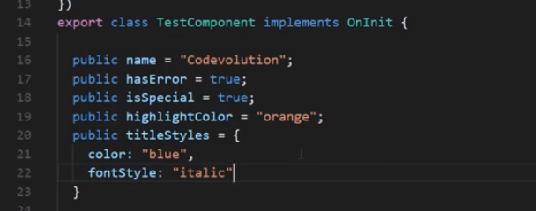

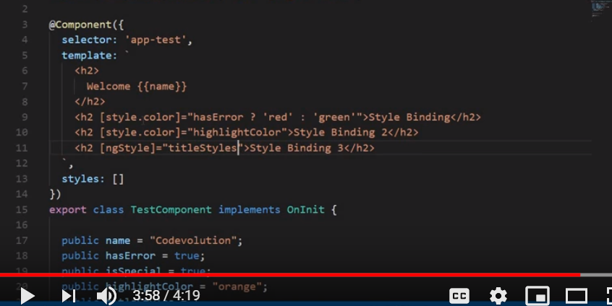

**Tutorial 6:---event binding**

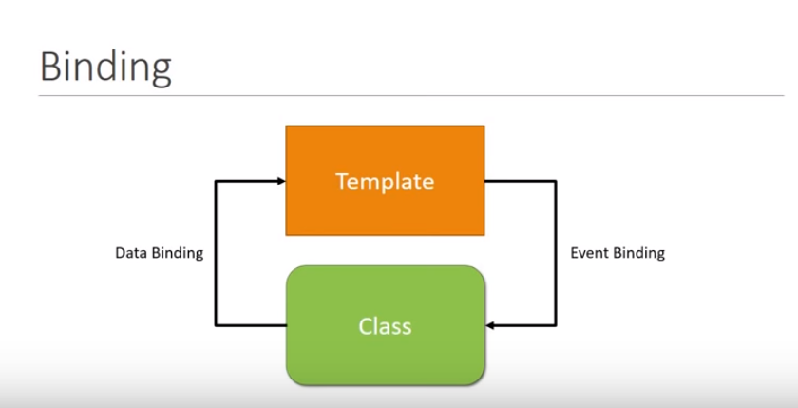

**By $event we can get access to all the property of dom event**

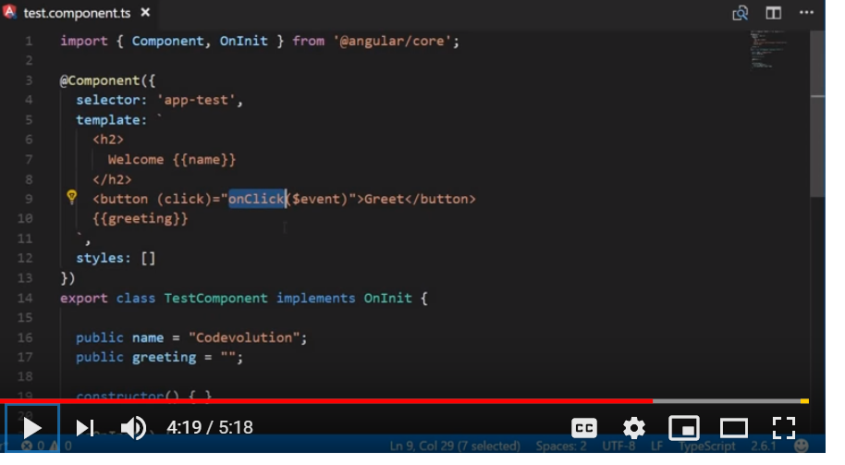

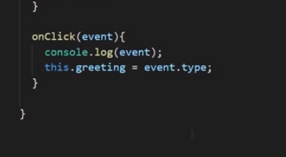

**Tutorial 6) template reference variable**

**We can create reference variable by #symbol followed by variable name**

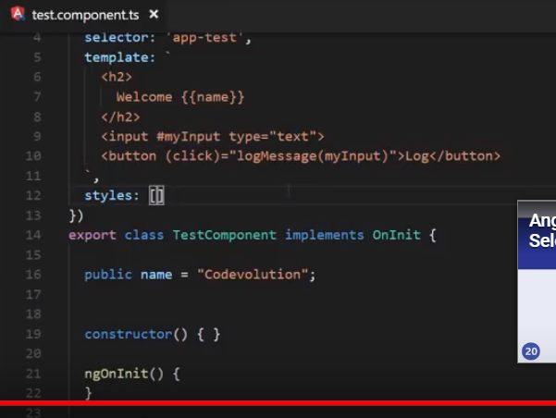

**Tutorial -7 ( two way binding)**

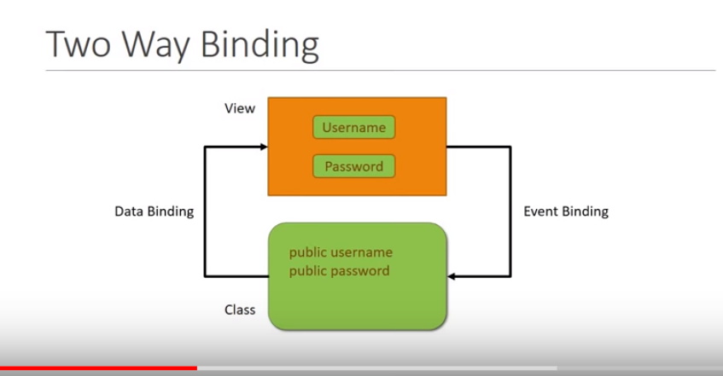

**[()]---banana in a box**

**[]-square bracket indicates data flow from component to template**

**()- parenthesis for event binding --bracket indicates data flow from template to component**

**Import forms module**

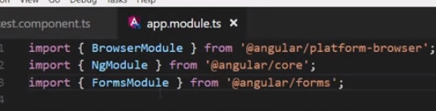

**Add in import array**

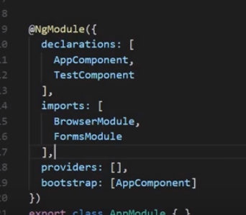

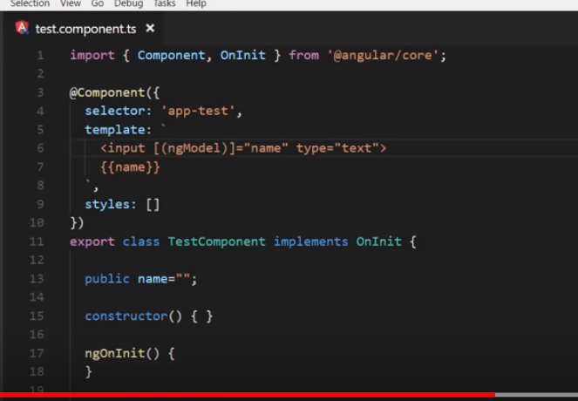

**Tutorial -8) ng-if**

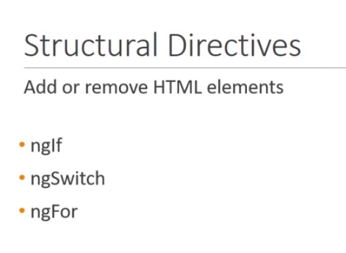

**\*ngIf**

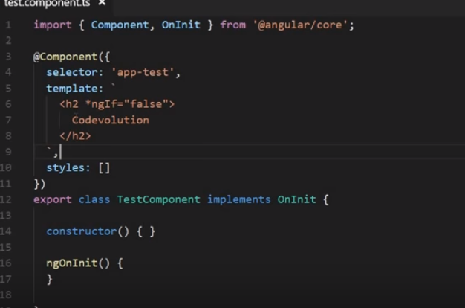

**If and else in ang 6**

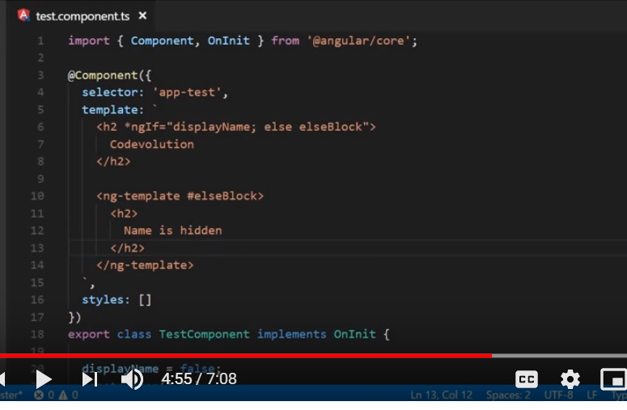

**Other way of displaying if and else**

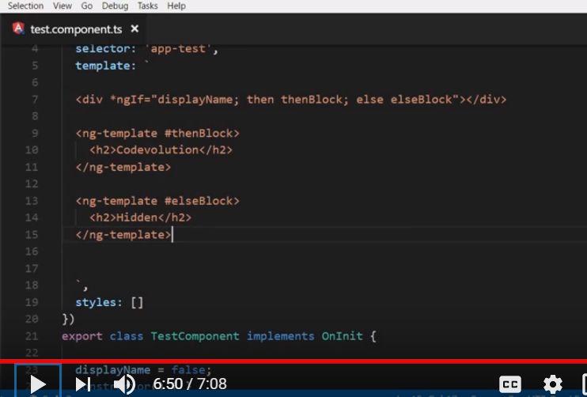

**b ) ngSwitch**

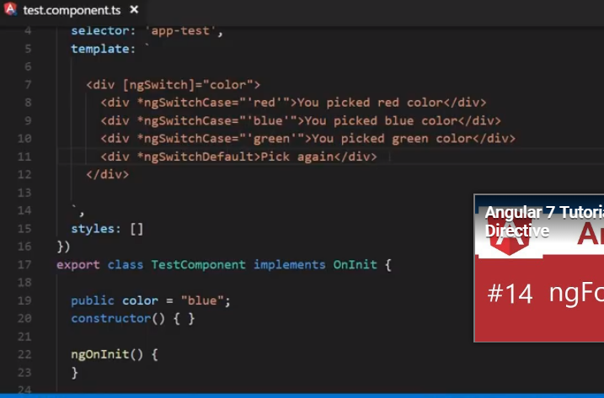

**c)ngFor------------- render list of element**

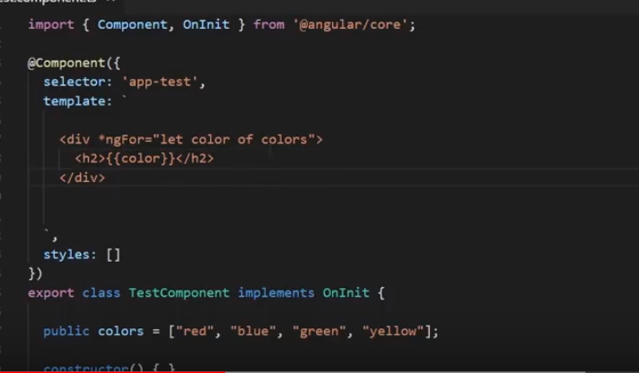

**Tutorial 8:- Component Interaction**

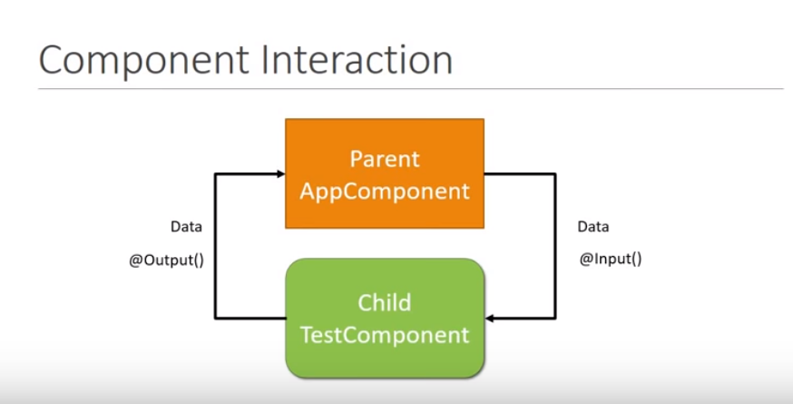

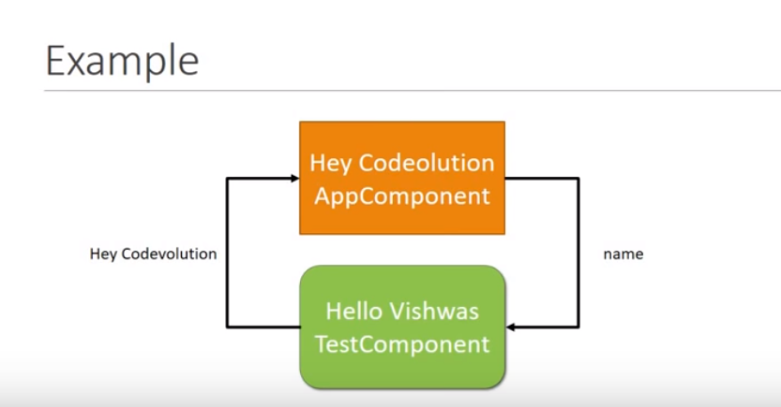

**Sending data from parent to child component**

**a)**

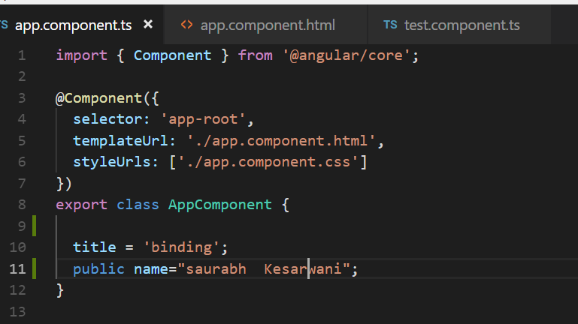

b)

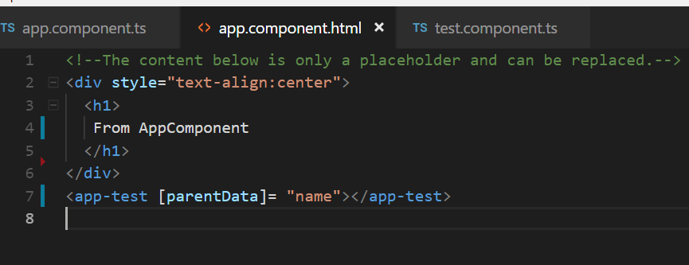

c)

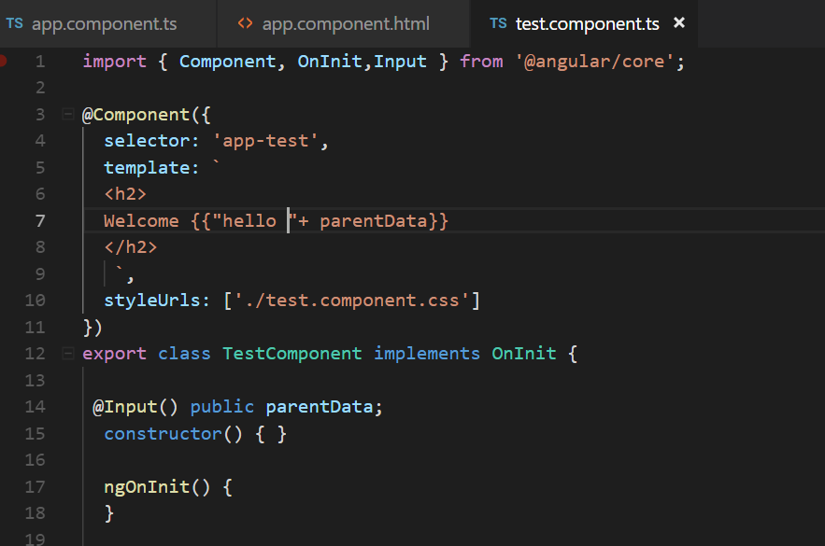

1. We can give our own name also

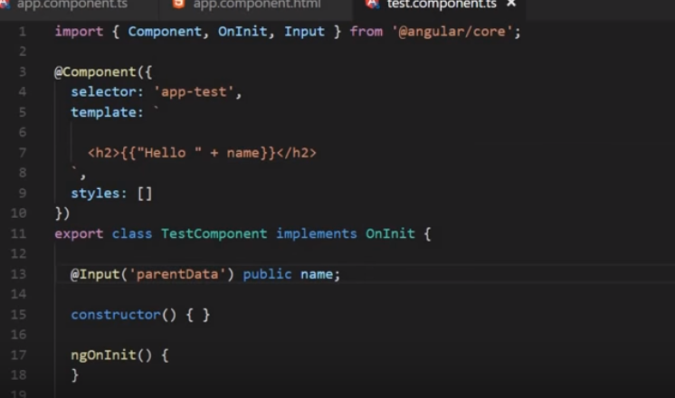

Sending data from child component to parent component

NOTE: on event fire we can send message from child to parent

a)

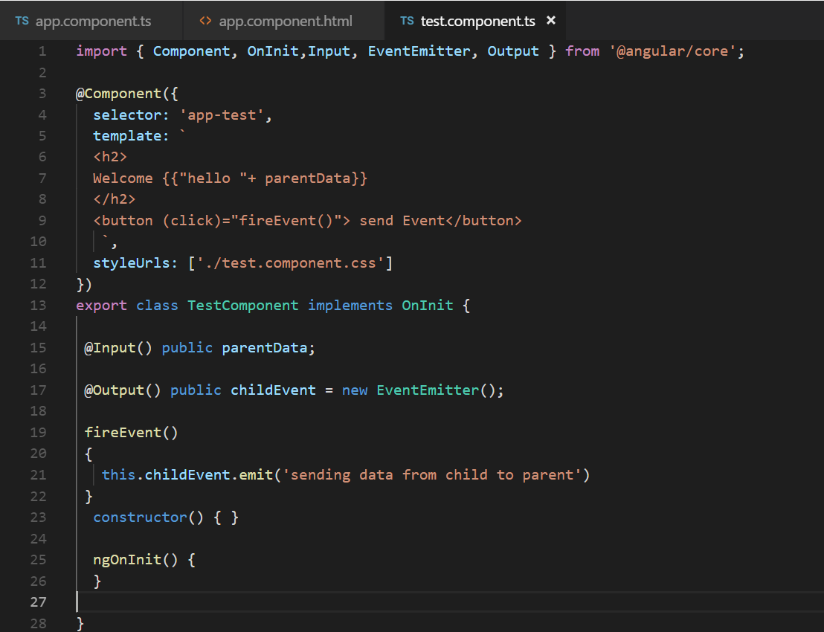

b)

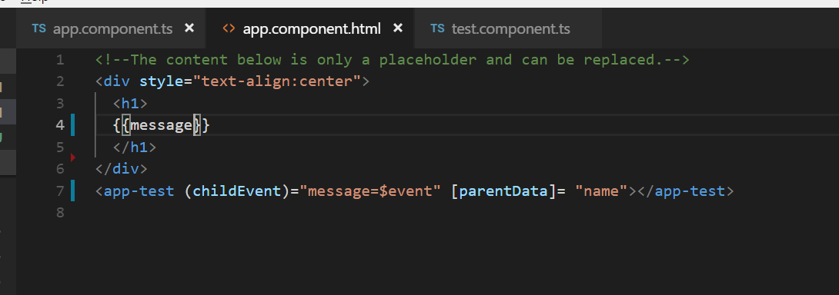

c)

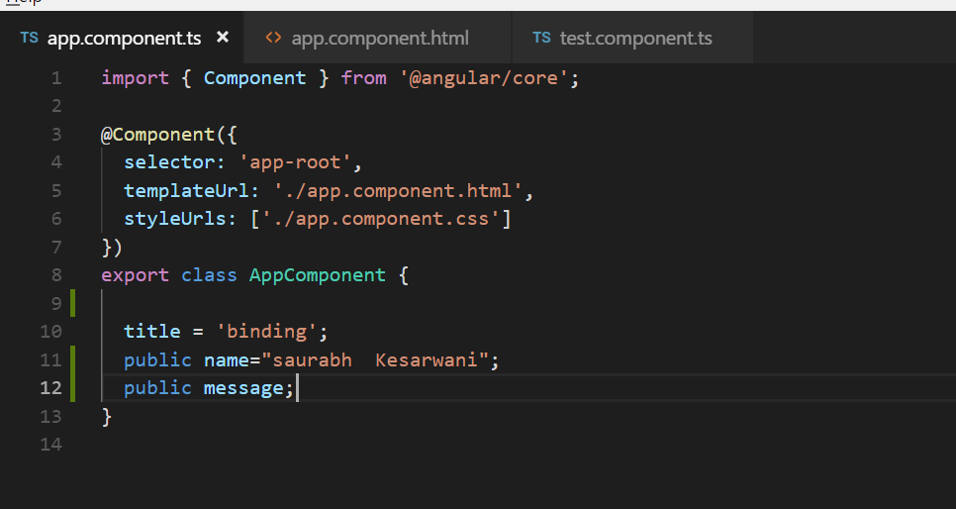

$event component given access to the argument that was send from child component

**Tutorial 9 ) pipes**

**Pipes:**

**titlecase : will do every first alphabet of word in caps**

**Slice: will take arguments**

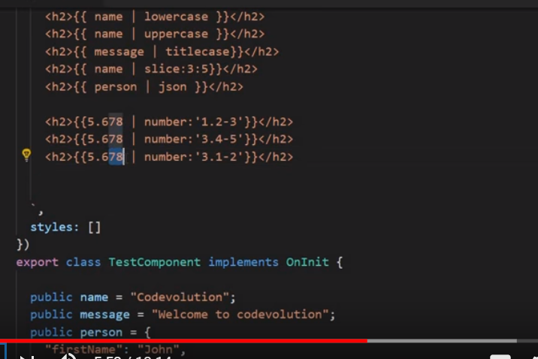

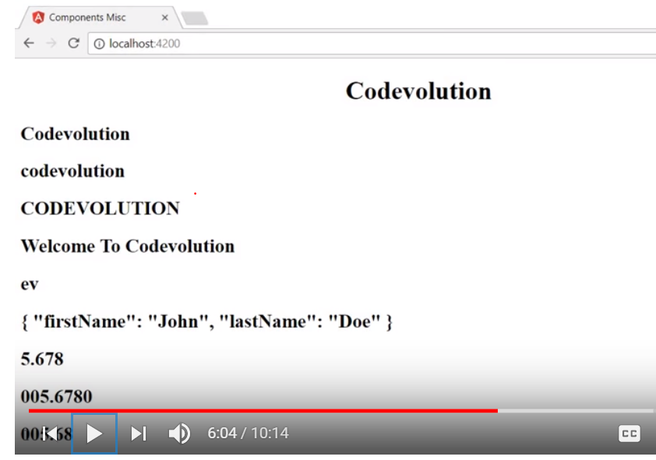

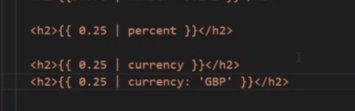

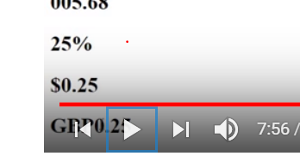

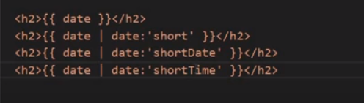

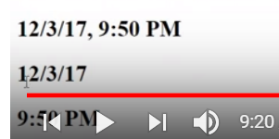

**Tutorial 10) Service**

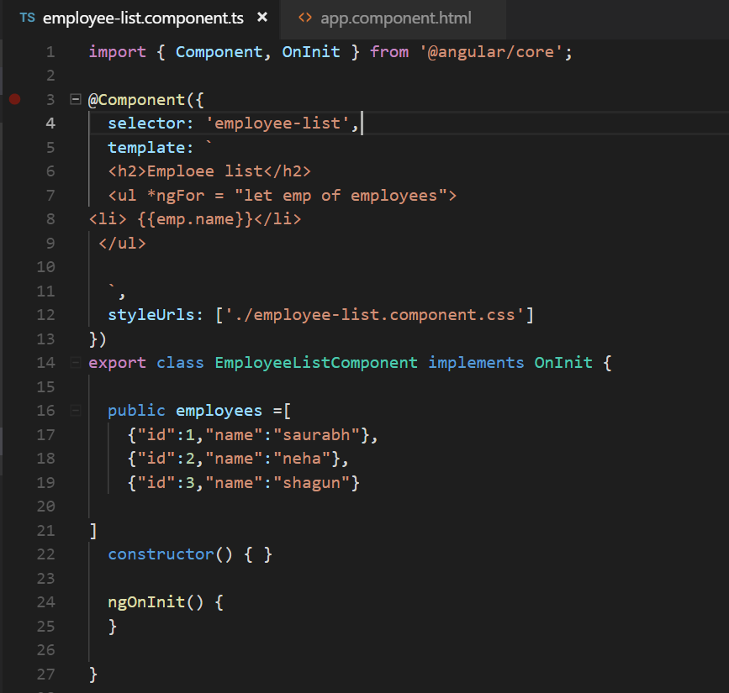

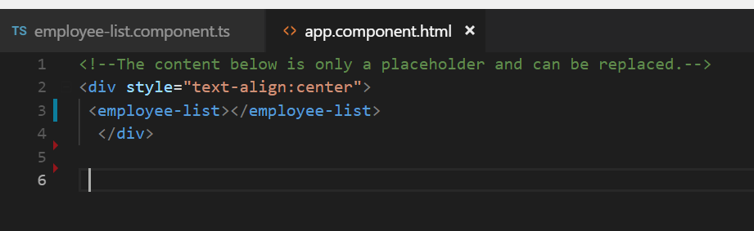

**Why we need service:-**

**To share data across multiple component**

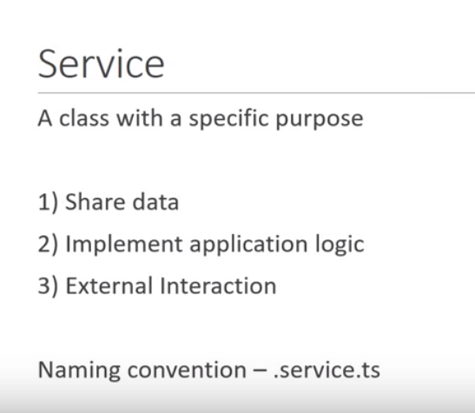

**Tutorial 11) dependency injection**

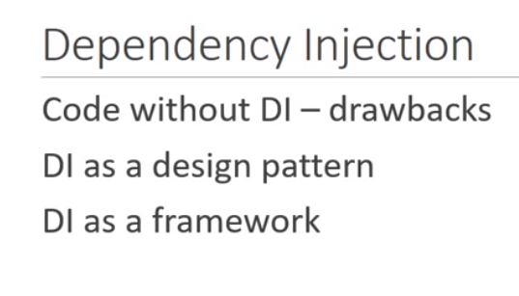

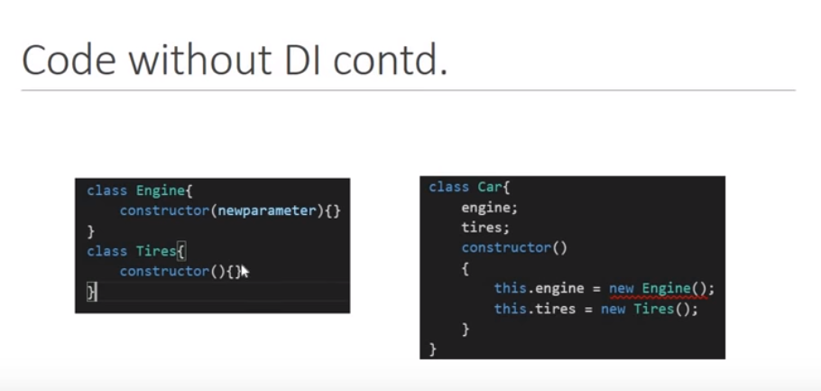

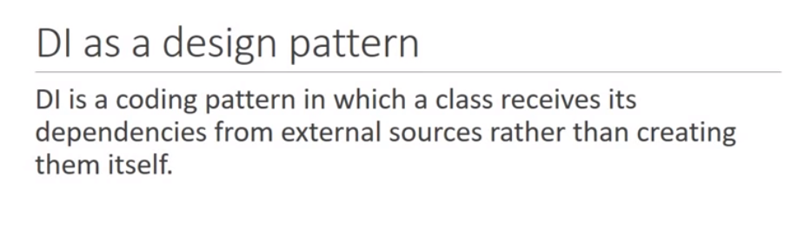

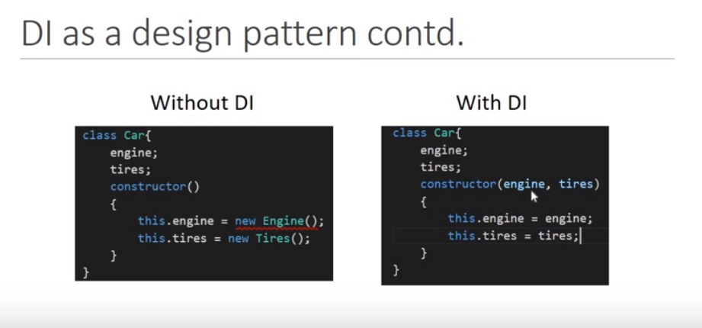

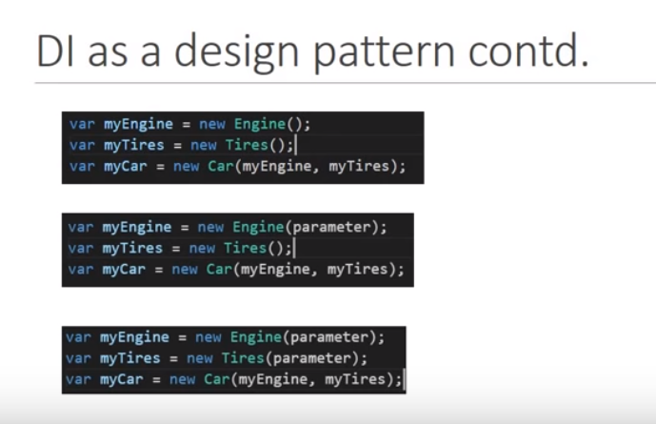

**Difficult for developer if so many dependency is given**

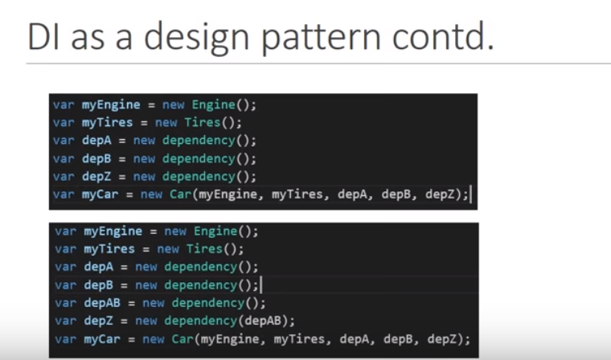

**Angular injector will provide all the dependency**

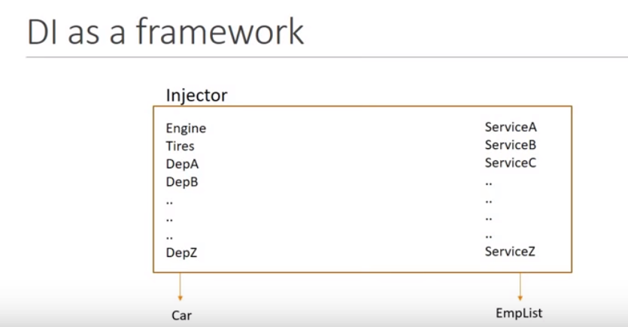

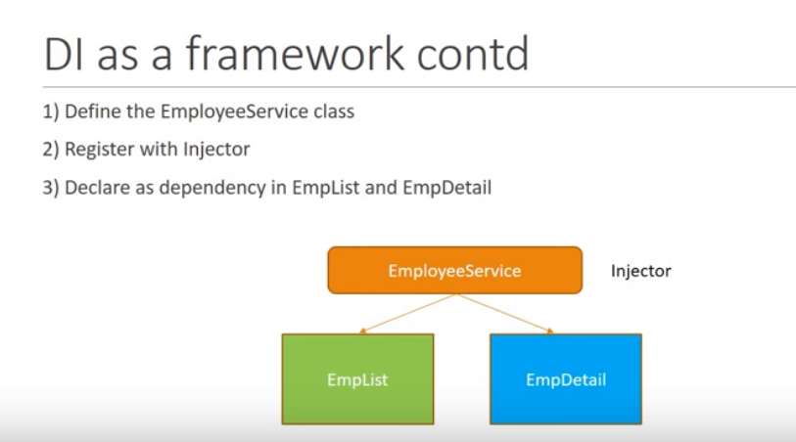

**Step 1) create a service**

**Ng g s employee( ng generate service employee)**

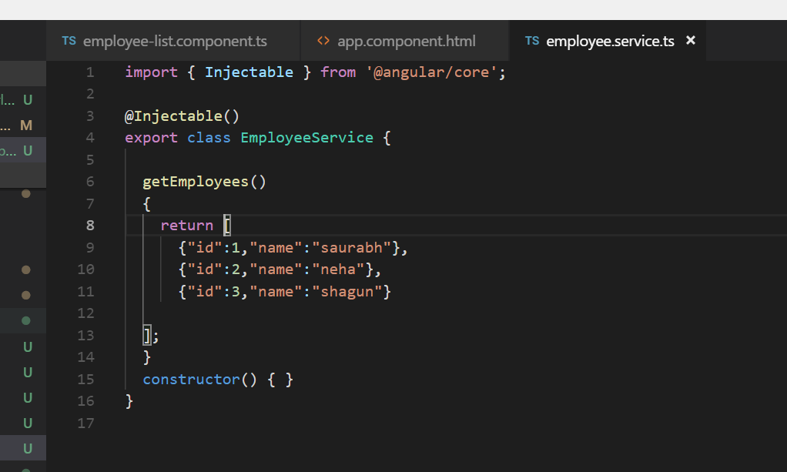

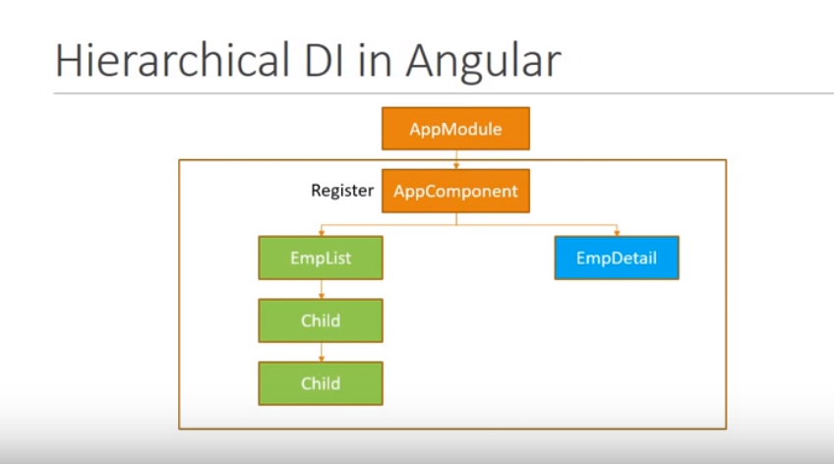

**Step 2:-Register service using provider metadata**

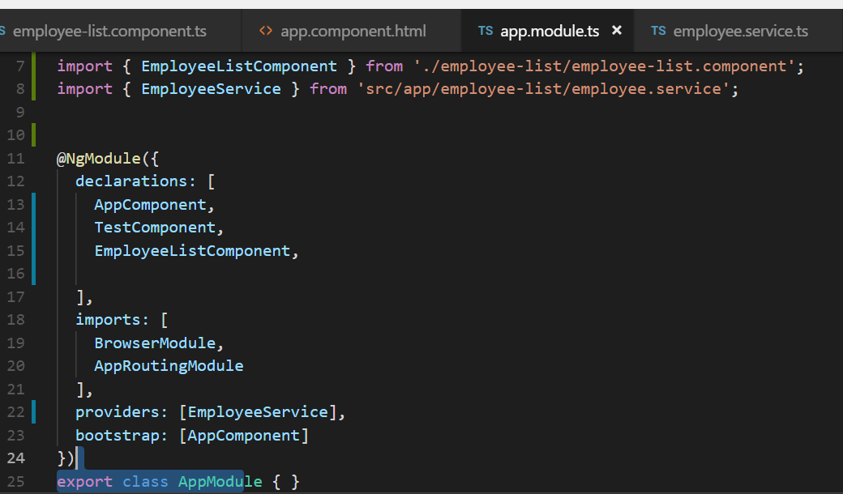

**Note dependency specify using constructor**

**ngOnInit---is invoked when the component has being initialized**

**@Injectable: decorator tell service might have dependency to another service**

**Is required only for service not for component**

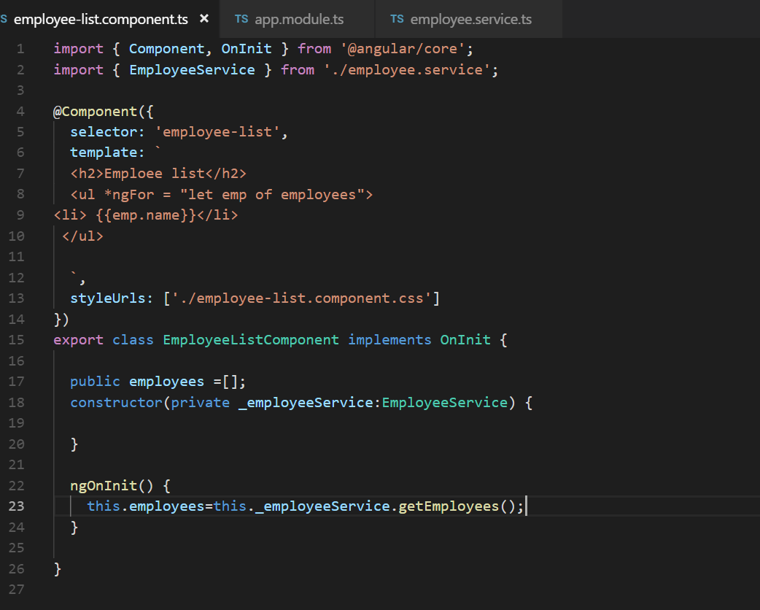

**Tutorial 12 ) http and observable**

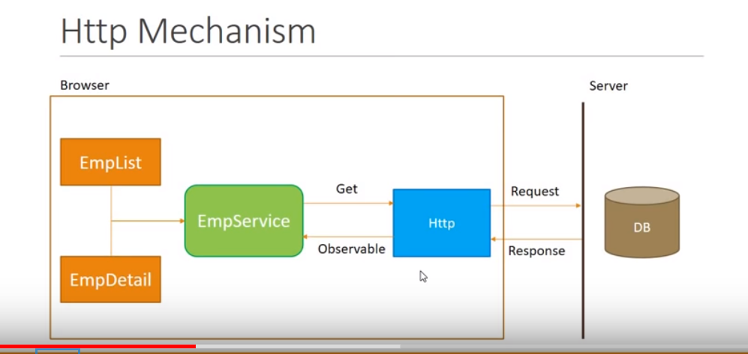

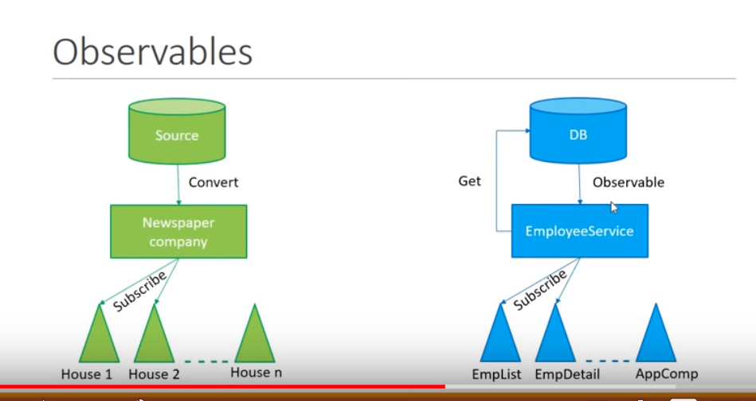

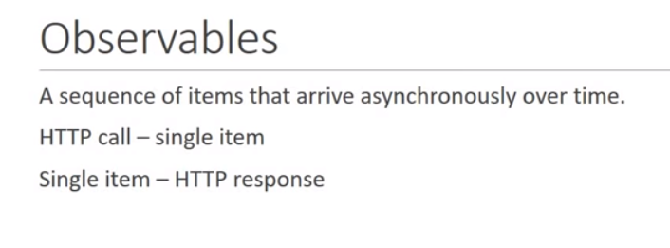

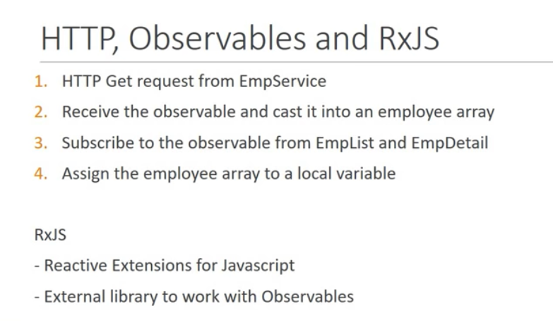

**// fetch data using http**

**1)define HttpClientModule**

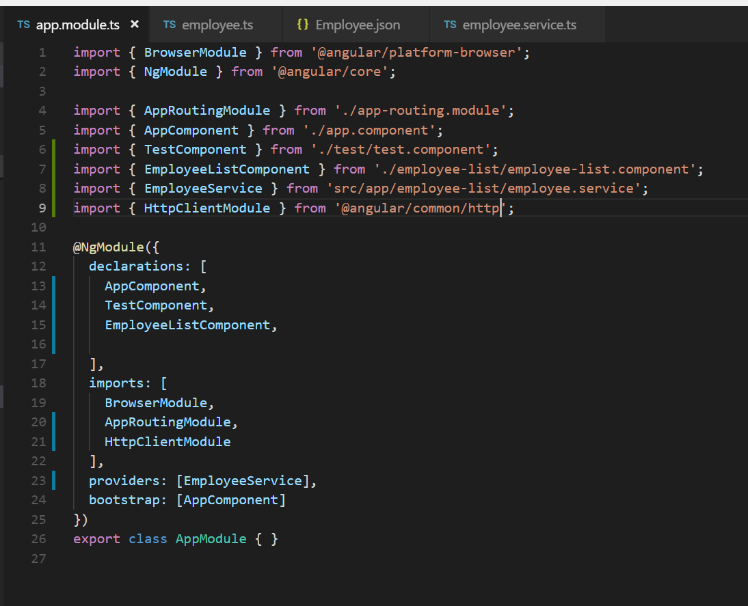

**2)Define interface**

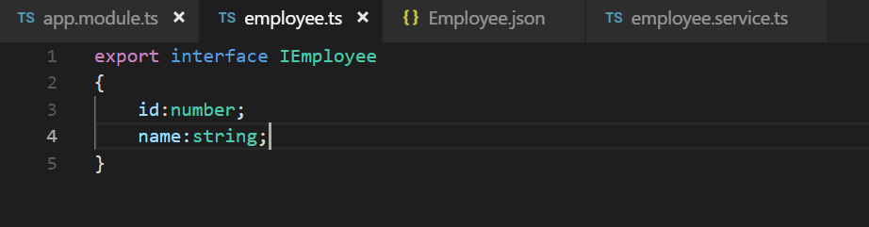

1. Employee.json

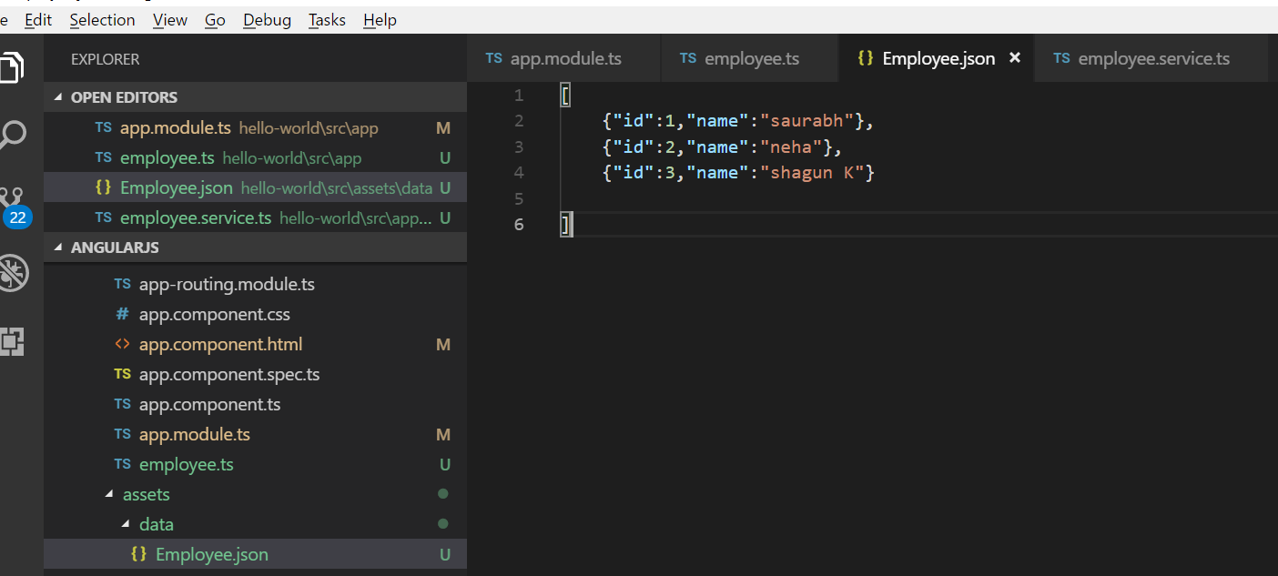

4)EmployeeService.ts

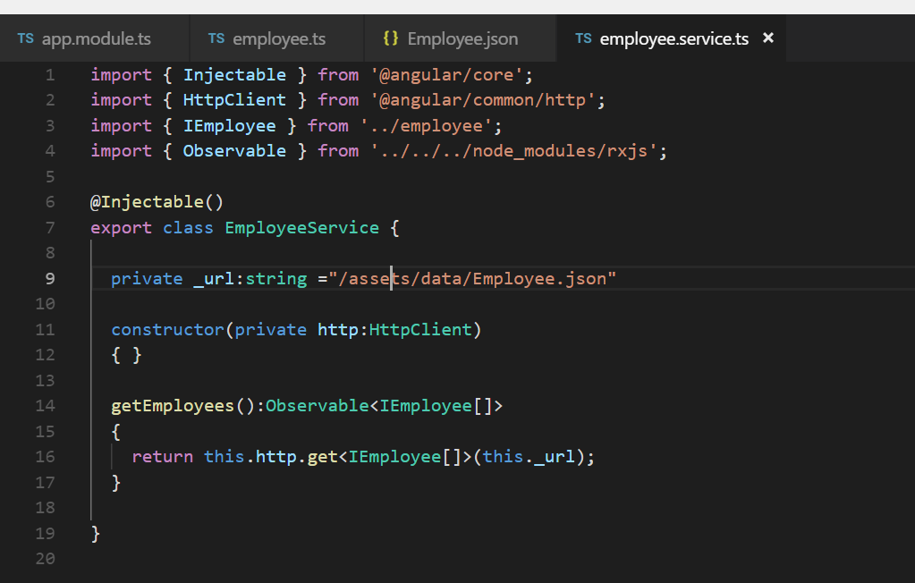

5)

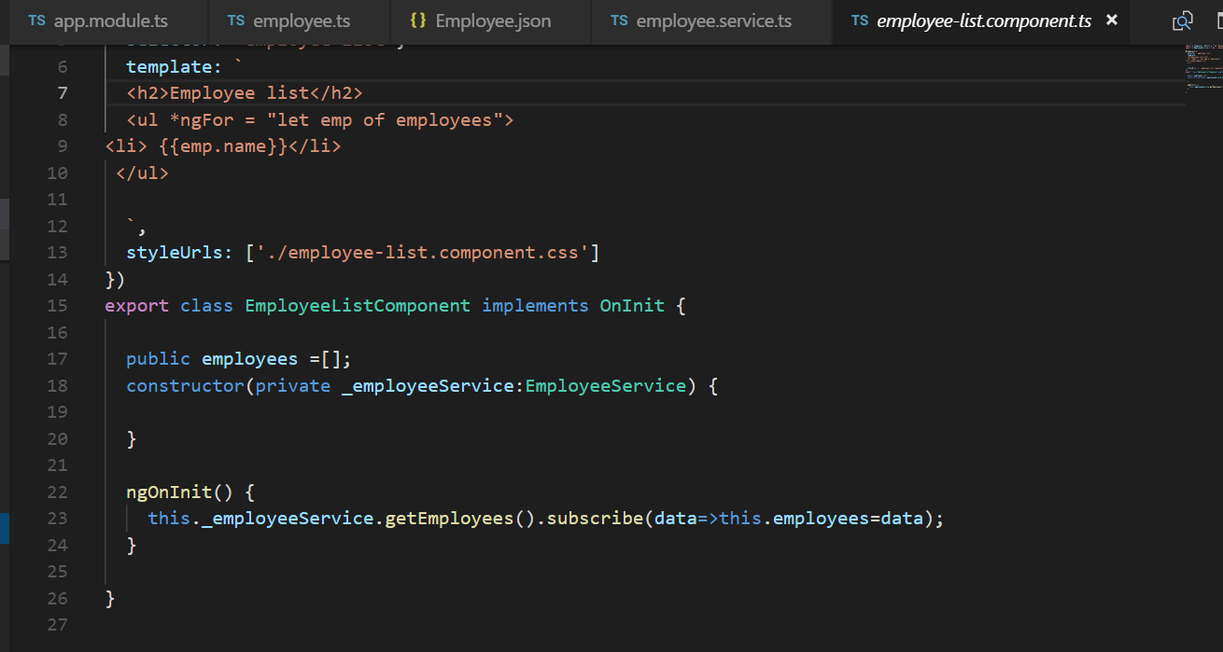

Observable doesn’t provide the data unless someone subscribe it

**Tutorial 13) routing and navigation**

**Any angular application has multiple component, each component has it own view.**

**Requirement: to navigate between different view when user perform some action then we use angular router**

**First)**

How to navigate between two views with button click

NOTE: based on URL we navigate appropriate view

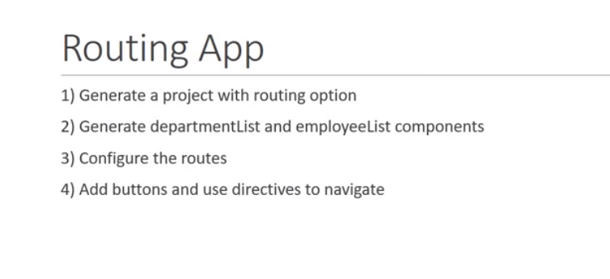

Ng g c department-list -it -is(inline template inline style)

Ng g c employee-list -it -is(inline template inline style)

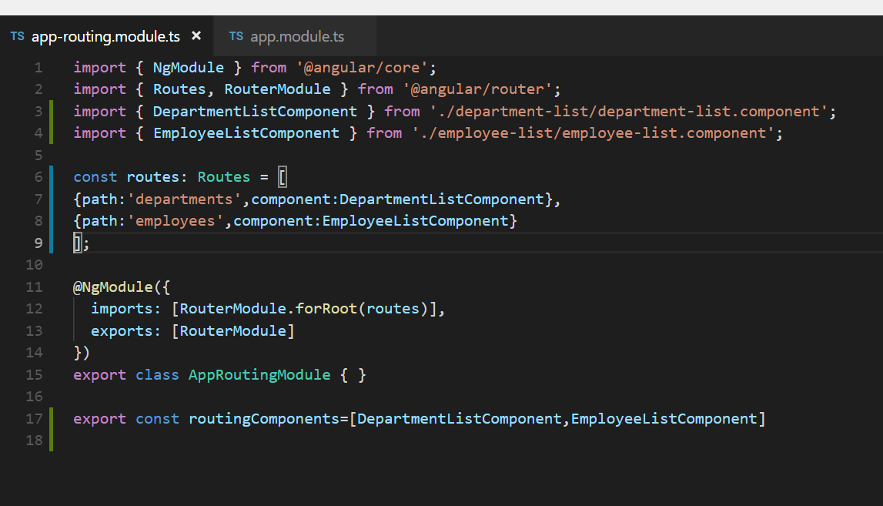

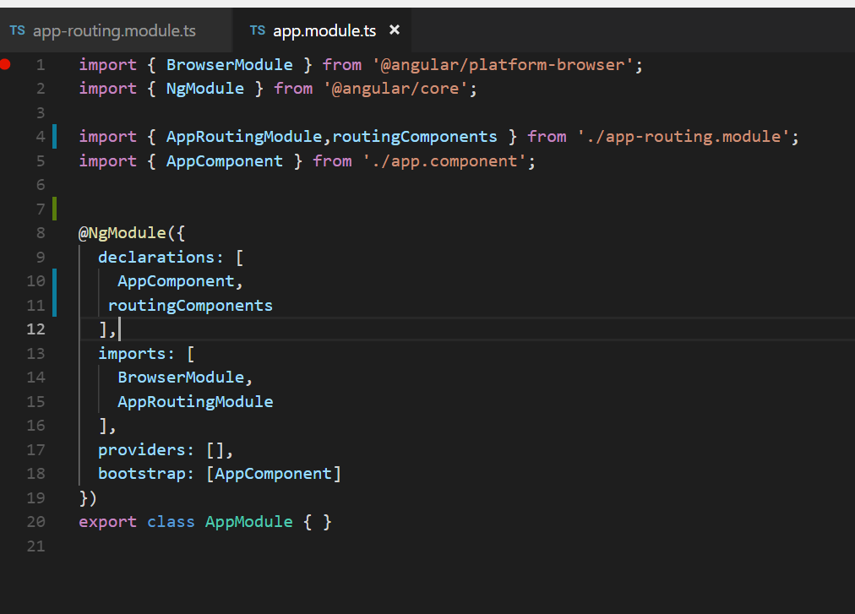

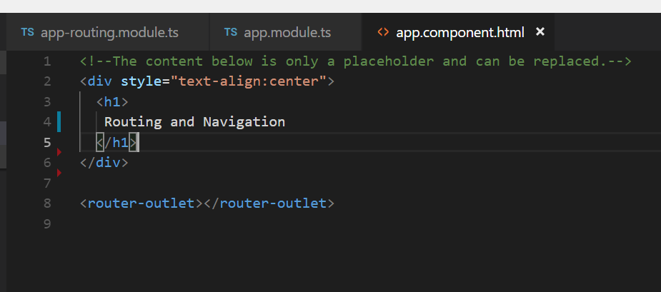

NOTE: router view goes in router outlet

<http://localhost:4200/employees>

[http://localhost:4200/](http://localhost:4200/employees)Departments

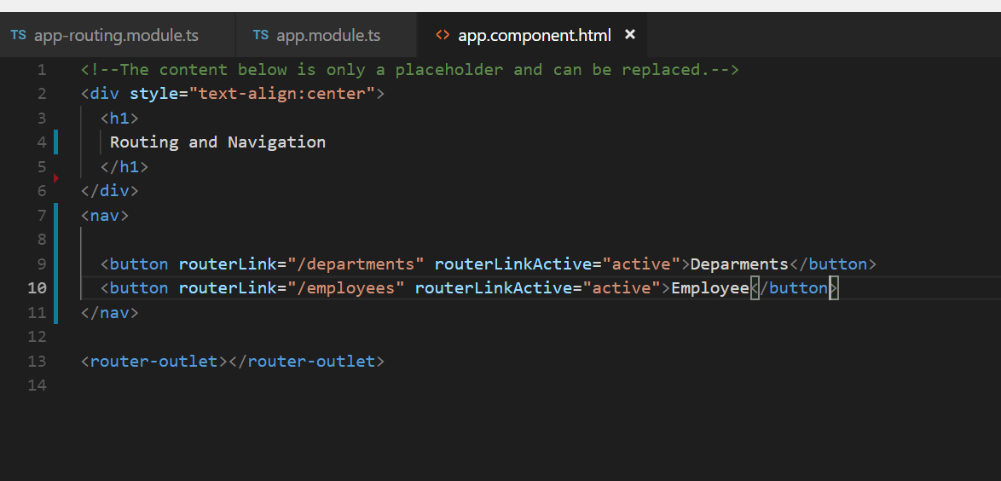

**Wildcard routes and redirect routes**

Note: if the user give wrong route it will throw error so we should use wildcard route and if url not matched

It will throw 404

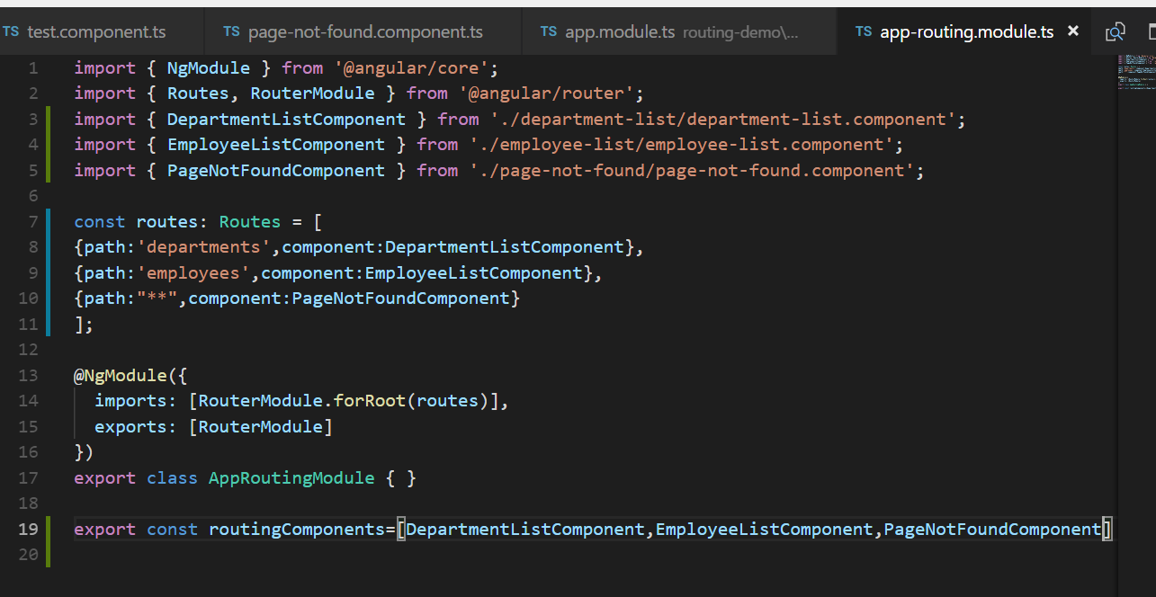

**Note :**  wildcard route should always be last route in configuration because router tried to match the path from the top

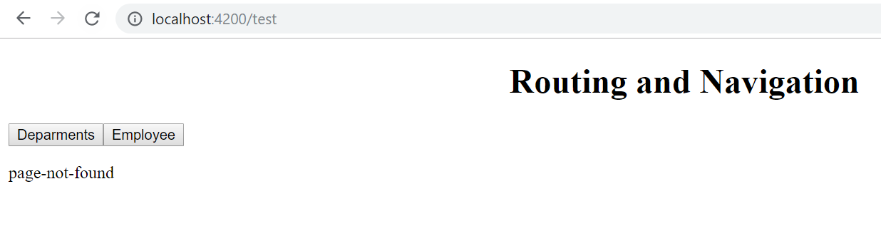

**Note:** Once we configure wild card route we face another problem because route not match

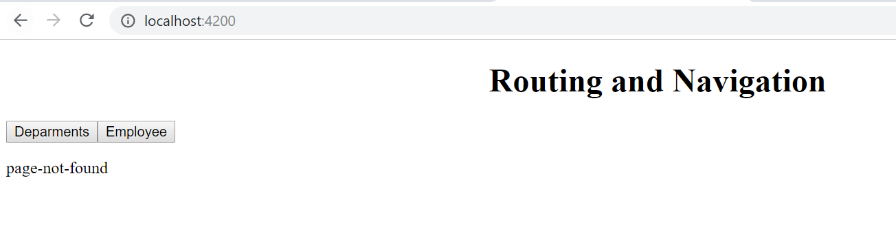

**Solution : our application require default path**

**pathMatch (property)** tell how to configure url segment with the configure route

pathMatch(full):---- if the url is complete then redirect it

Important

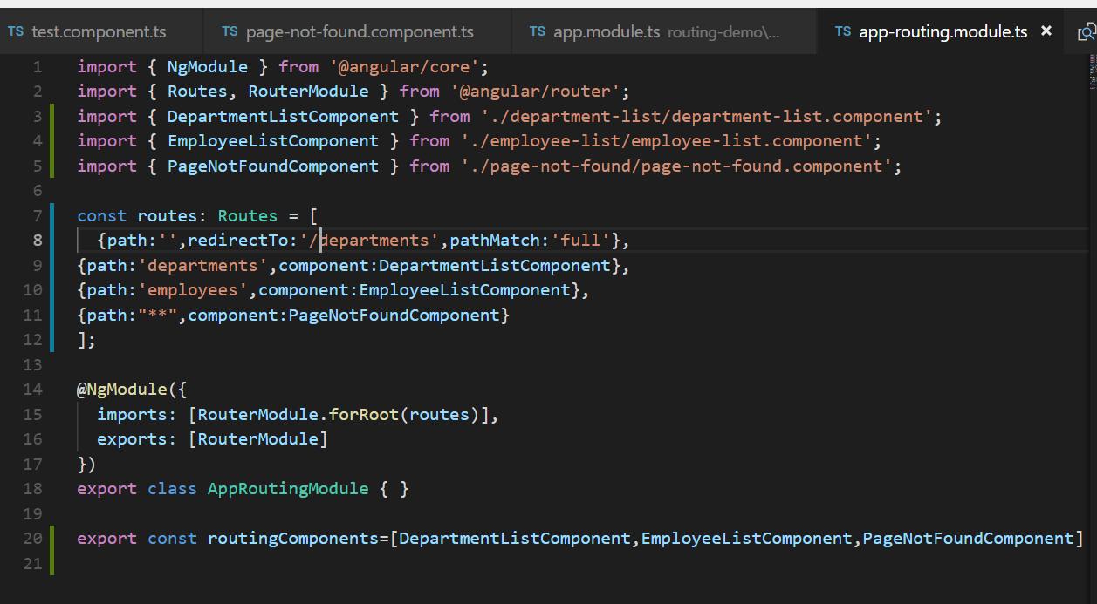

pathMatch: 'full' means, that the whole URL path needs to match and is consumed by the route matching algorithm.

pathMatch: 'prefix' means, the first route where the path matches the start of the URL is chosen, but then the route matching algorithm is continuing searching for matching child routes where the rest of the URL matches.

**Route Parameter**

**Task : passing and reading route paramter**

**Ng g c department-detail -it -is**

**First step:\\**

Want to pass parameter from department then read it that parameter in department detail

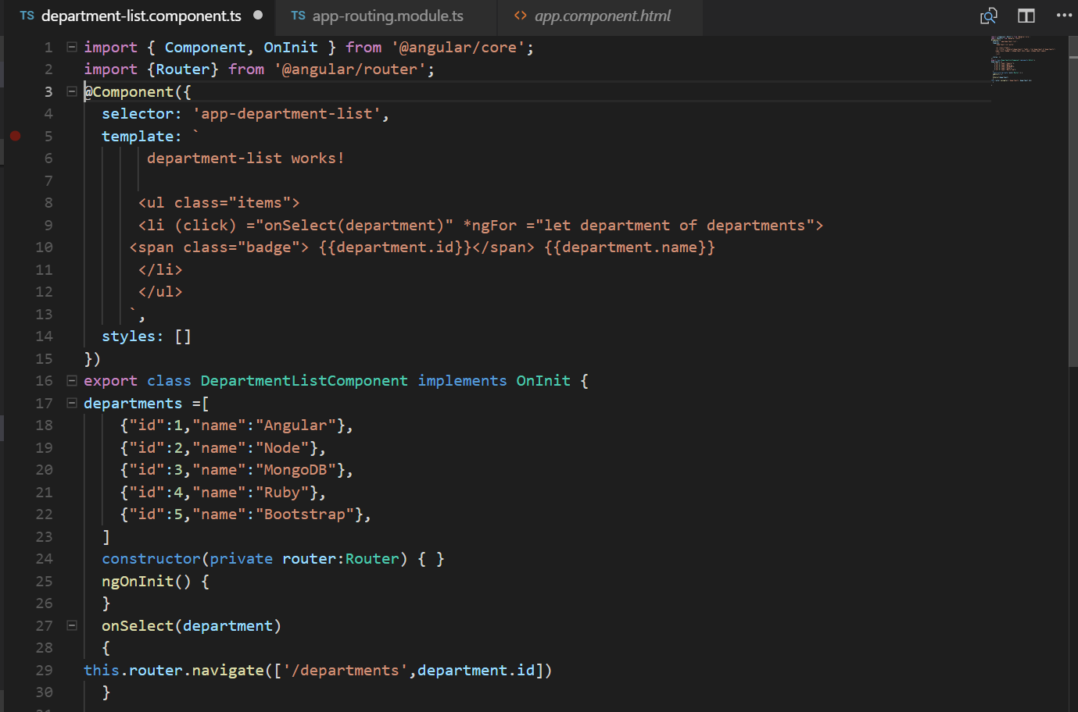

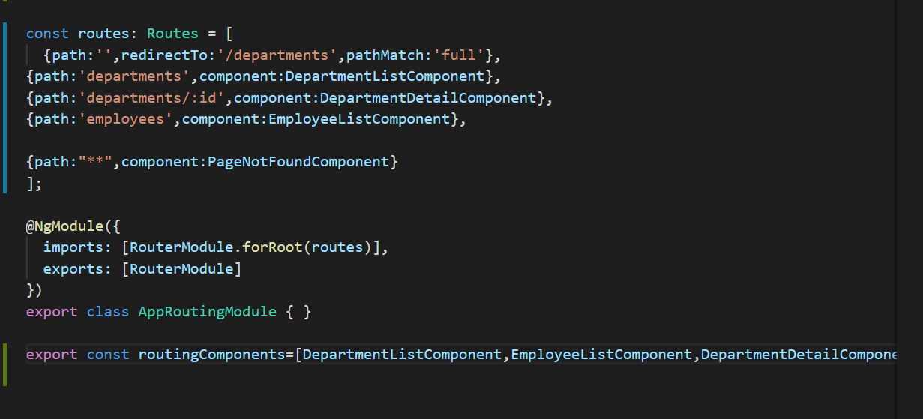

this.router.navigate

: it is require by angular to construct a url

**2)**

**Note : to read the parameter we need to import**

import { ActivatedRoute} from '@angular/router';

Then inject it in the constructor

**Note**

**In constructor we inject it to get the object**

**In ngOnInit method** we read the route parameter

This.route.snapshot========give the current routr

This.route.snapshot.paramMap.get('id') which help us to get parameter from the url

NOTE: from the current route snapshot get the id parameter from the url

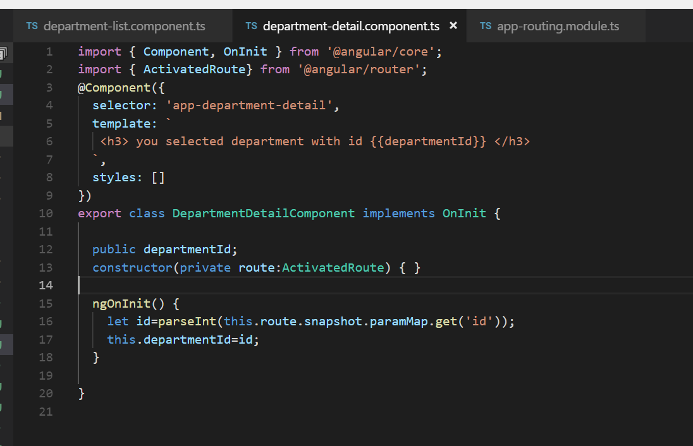

//output

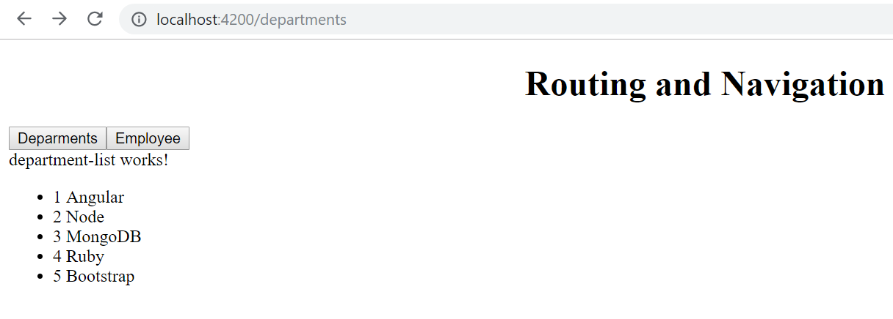

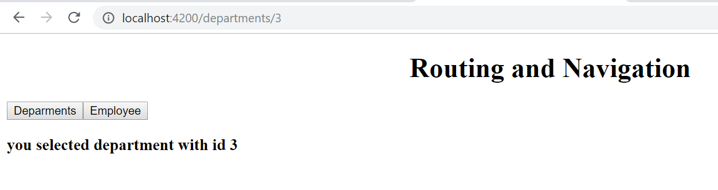

**paramMap Observable**

**Using** ActivatedRoute Has a drawback

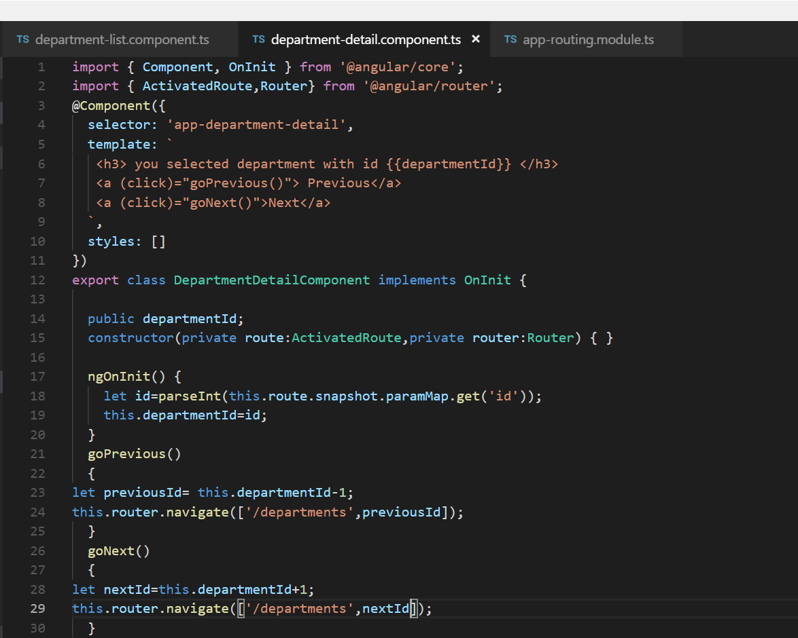

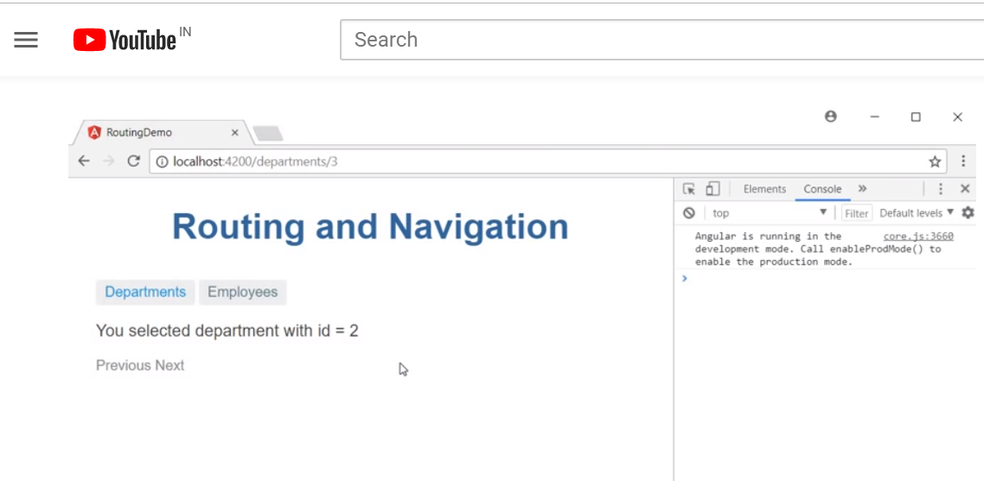

Url id is changing by clicking next but you selected department with id 2 is not changing. This is the drawback of using snapshot

**NOTE**

**When we back to same component angular uses the old component and ngOnInit is not initialized that’s why snapshot method never called**

**SOLUTION**

**Use paramMap**

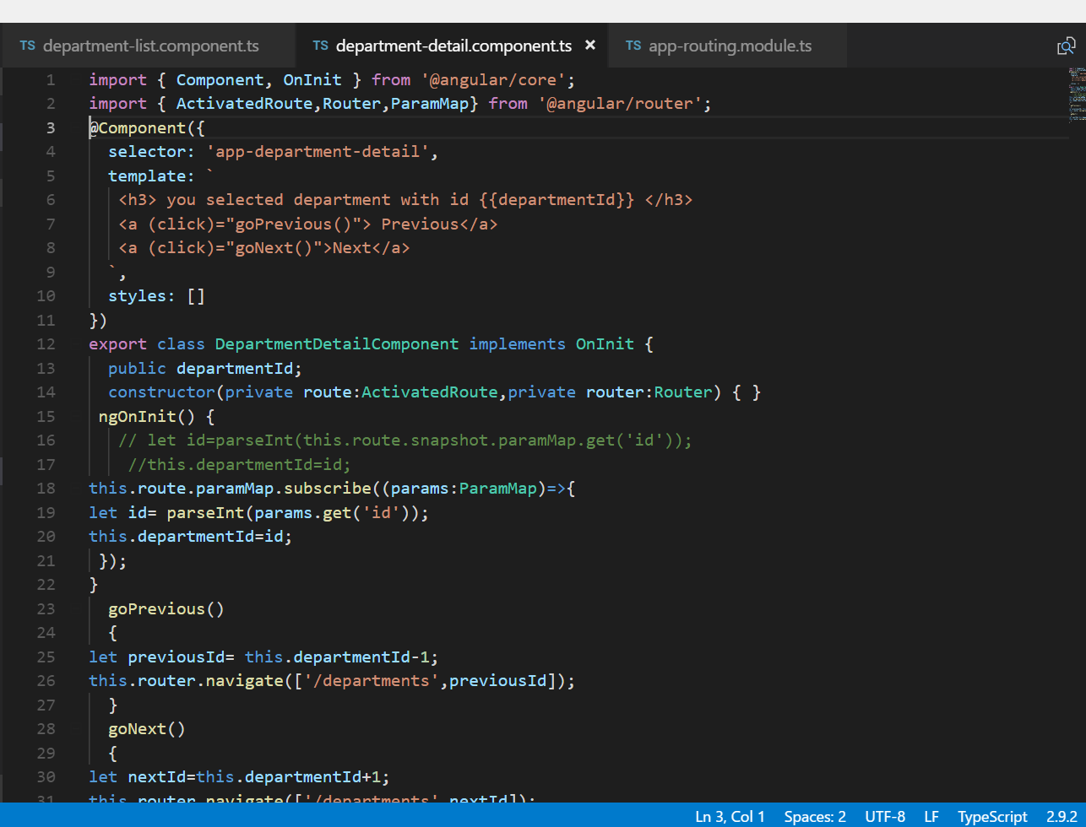

**Optional Route parameter**

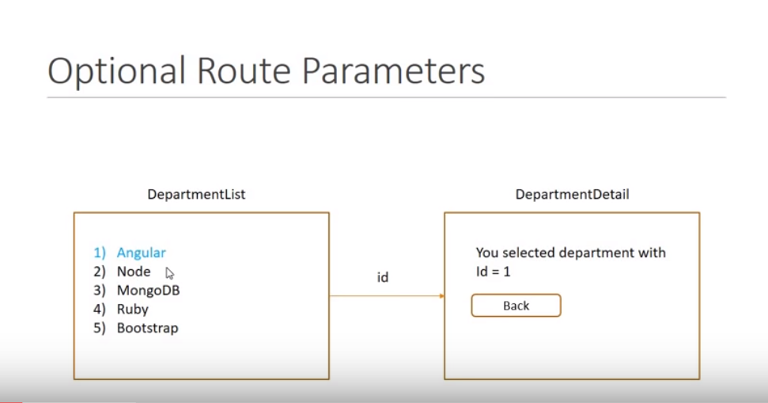

**New Requirement:** when we click on back it will redirect to departmentList and it should be highlighted\

And this can be achieve using optional route parameters

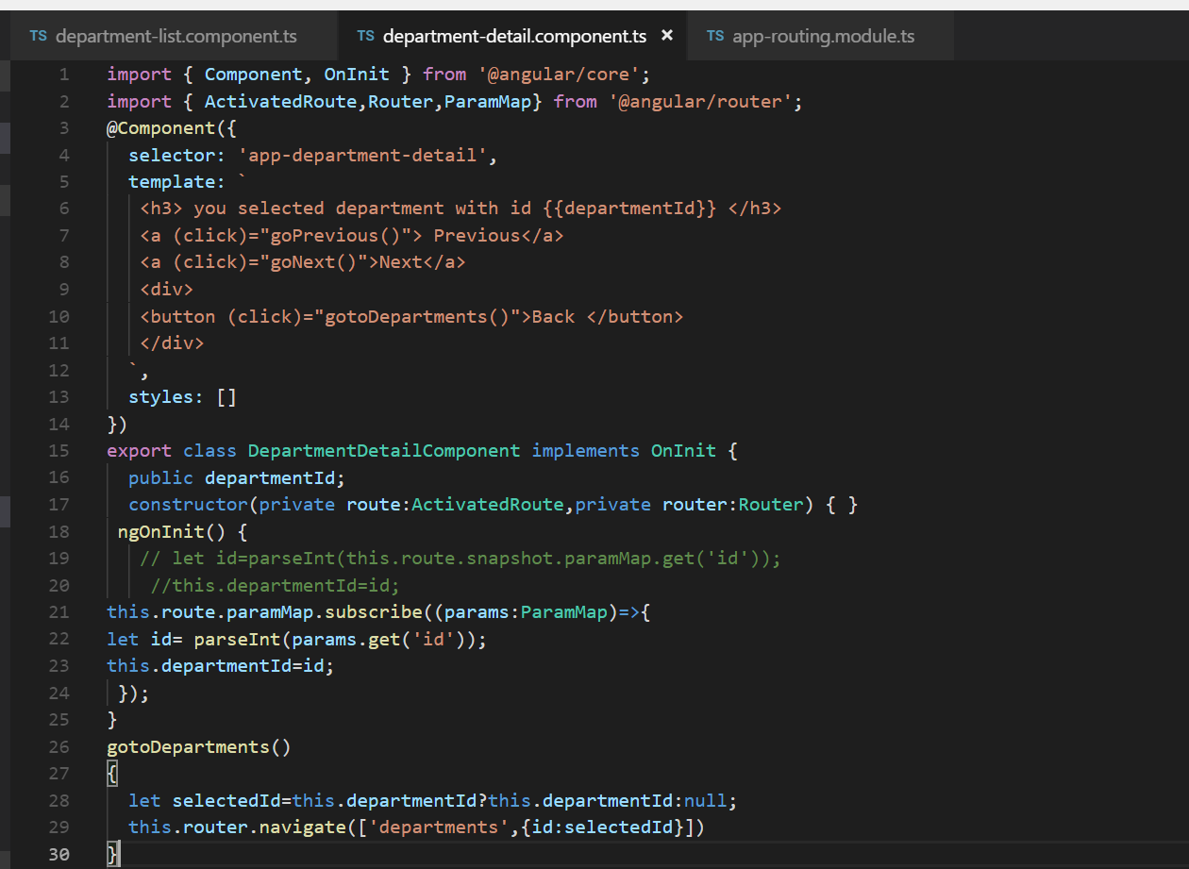

Id=3 is the optional route parameter

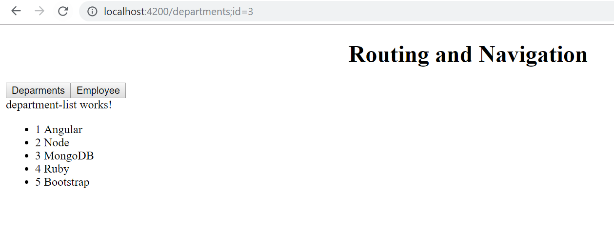

**to send id and get id**

constructor(private router:Router,private route :ActivatedRoute) { }

ngOnInit() {

this.route.paramMap.subscribe((params:ParamMap)=>{

let id= parseInt(params.get('id'));

this.selectedId=id;

});

}

onSelect(department)

{

this.router.navigate(['/departments',department.id])

}

===============================================================

**departmentListComponent.ts**

Import { Component, OnInit } from '@angular/core';

import {Router,ActivatedRoute,ParamMap} from '@angular/router';

@Component({

selector: 'app-department-list',

template: `

department-list works!

<ul class="items">

<li (click) ="onSelect(department)" [class.selected]="isSelected(department)" *ngFor ="let department of departments">

<span class="badge"> {{department.id}}</span> {{department.name}}

</li>

</ul>

`,

styles: []

})

export class DepartmentListComponent implements OnInit {

public selectedId;

departments =[

{"id":1,"name":"Angular"},

{"id":2,"name":"Node"},

{"id":3,"name":"MongoDB"},

{"id":4,"name":"Ruby"},

{"id":5,"name":"Bootstrap"},

]

constructor(private router:Router,private route :ActivatedRoute) { }

ngOnInit() {

this.route.paramMap.subscribe((params:ParamMap)=>{

let id= parseInt(params.get('id'));

this.selectedId=id;

});

}

onSelect(department)

{

this.router.navigate(['/departments',department.id])

}

isSelected(department)

{

return department.id===this.selectedId;

}

}

==============

Department-detail.component.ts

import { Component, OnInit } from '@angular/core';

import { ActivatedRoute,Router,ParamMap} from '@angular/router';

@Component({

selector: 'app-department-detail',

template: `

<h3> you selected department with id {{departmentId}} </h3>

<a (click)="goPrevious()"> Previous</a>

<a (click)="goNext()">Next</a>

<div>

<button (click)="gotoDepartments()">Back </button>

</div>

`,

styles: []

})

export class DepartmentDetailComponent implements OnInit {

public departmentId;

constructor(private route:ActivatedRoute,private router:Router) { }

ngOnInit() {

// let id=parseInt(this.route.snapshot.paramMap.get('id'));

//this.departmentId=id;

this.route.paramMap.subscribe((params:ParamMap)=>{

let id= parseInt(params.get('id'));

this.departmentId=id;

});

}

gotoDepartments()

{

let selectedId=this.departmentId?this.departmentId:null;

this.router.navigate(['departments',{id:selectedId}])

}

goPrevious()

{

let previousId= this.departmentId-1;

this.router.navigate(['/departments',previousId]);

}

goNext()

{

let nextId=this.departmentId+1;

this.router.navigate(['/departments',nextId]);

}

}

App-routingmodule.ts

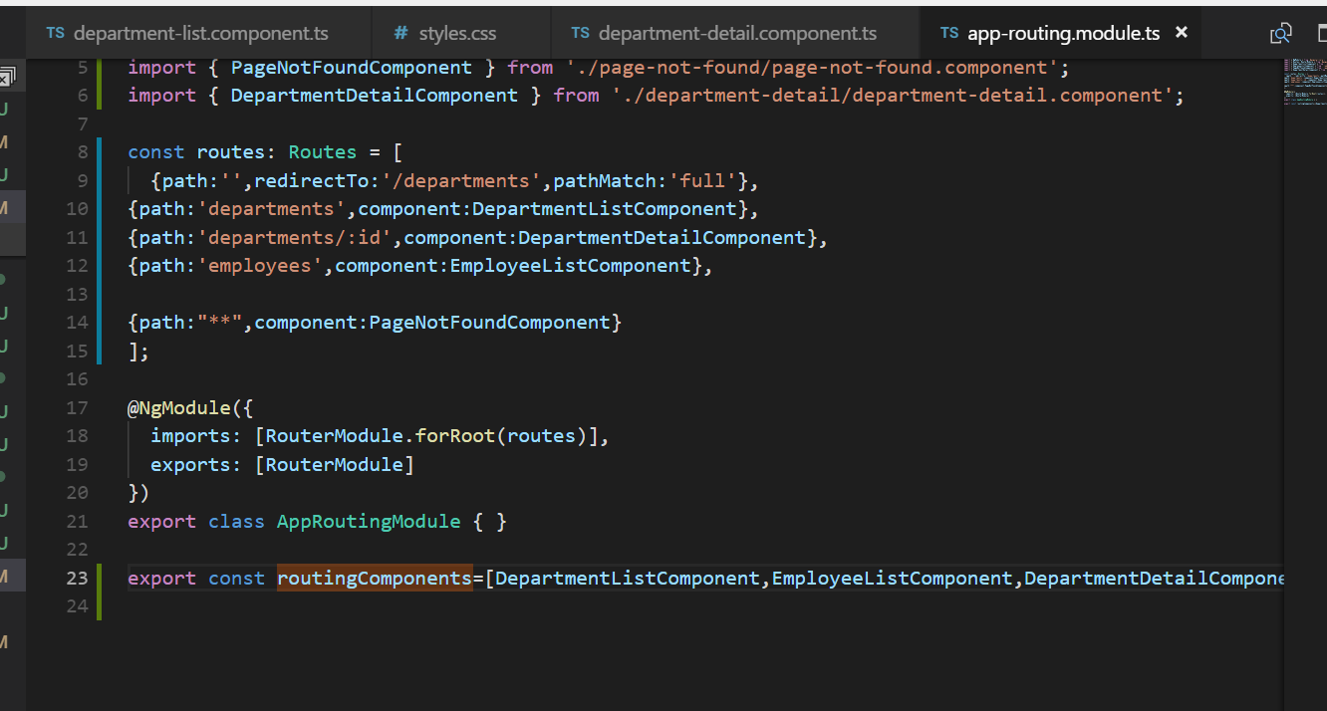

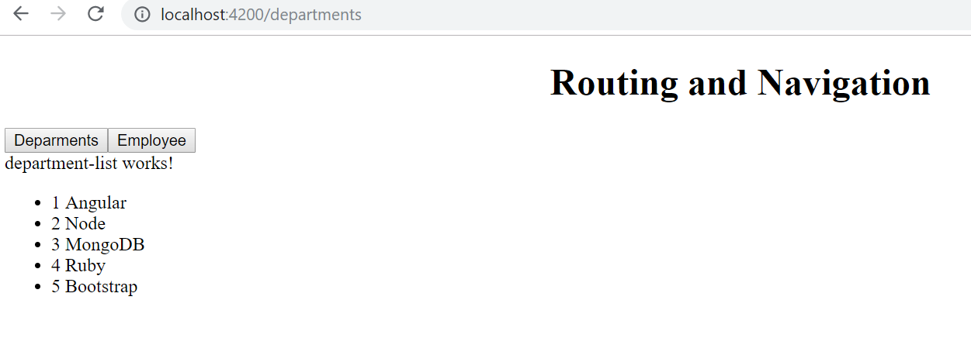

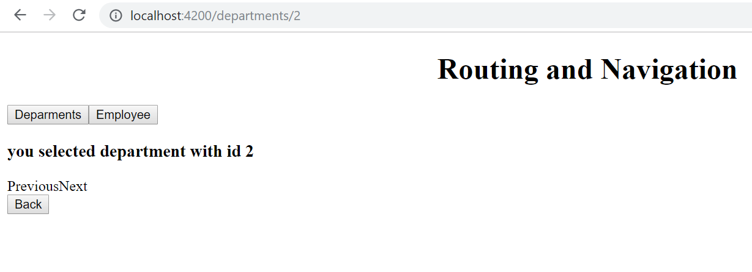

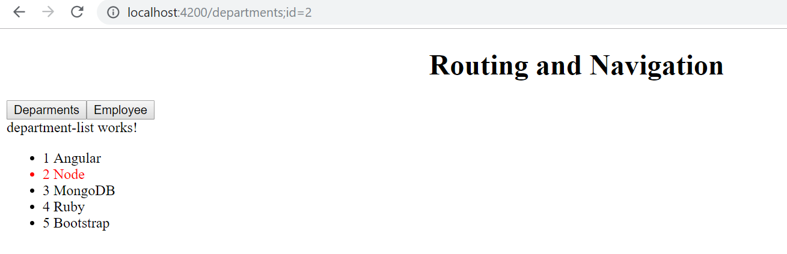

**Relative navigation**

**Note: to the current route append the id**

this.router.navigate([department.id],{relativeTo:this.route})

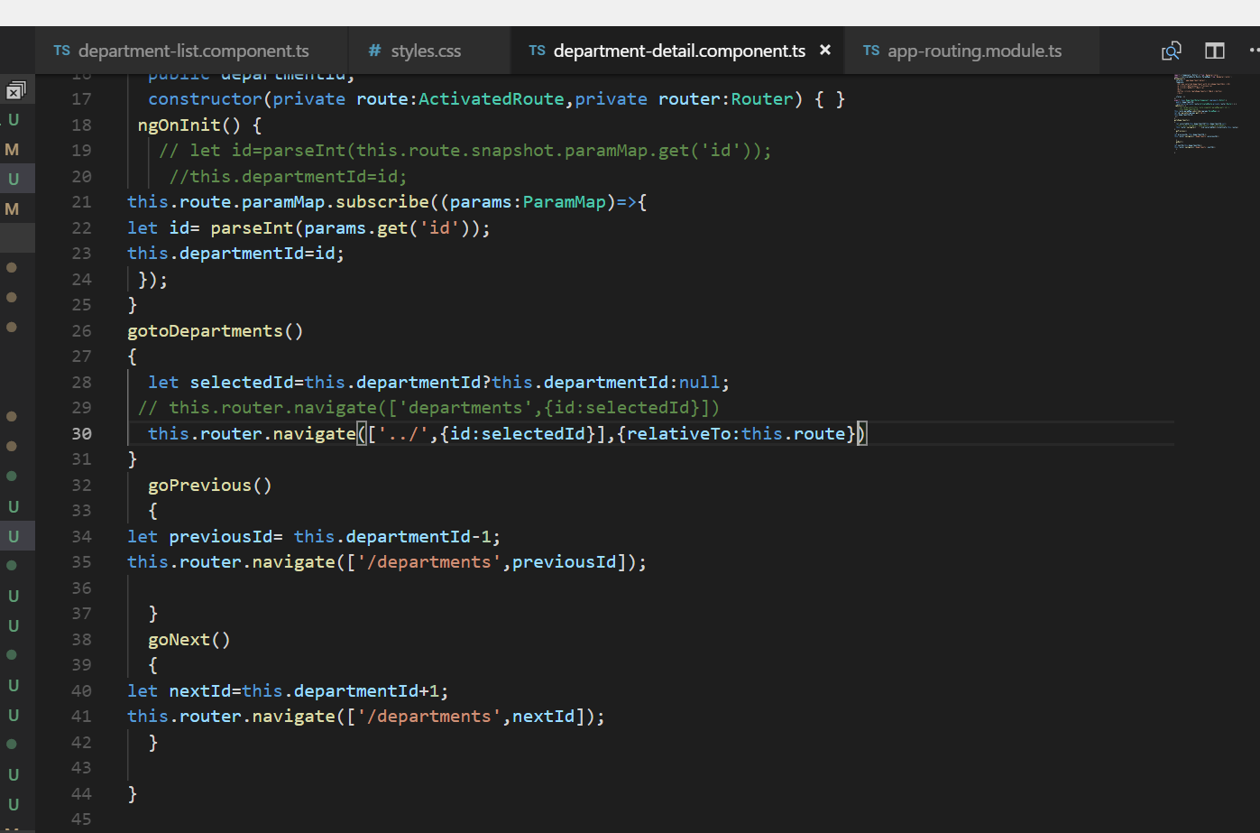

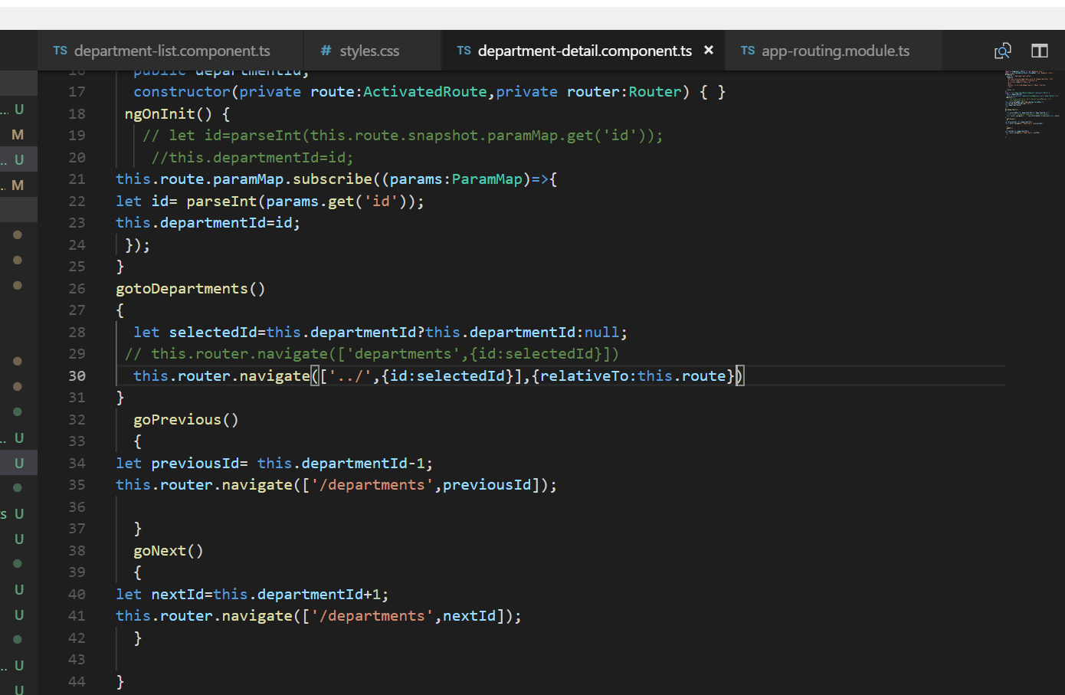

**Child routes**

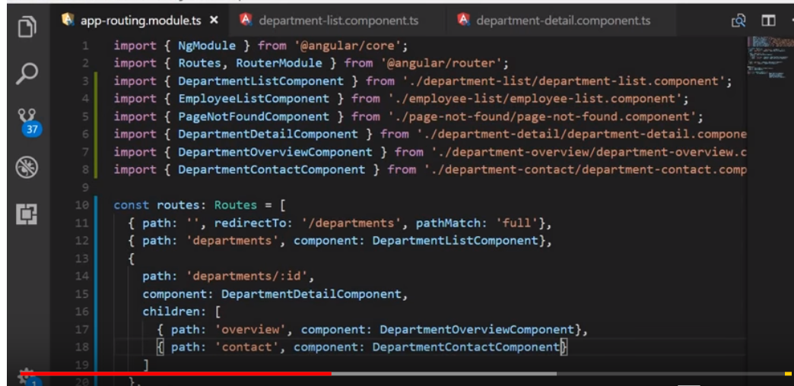

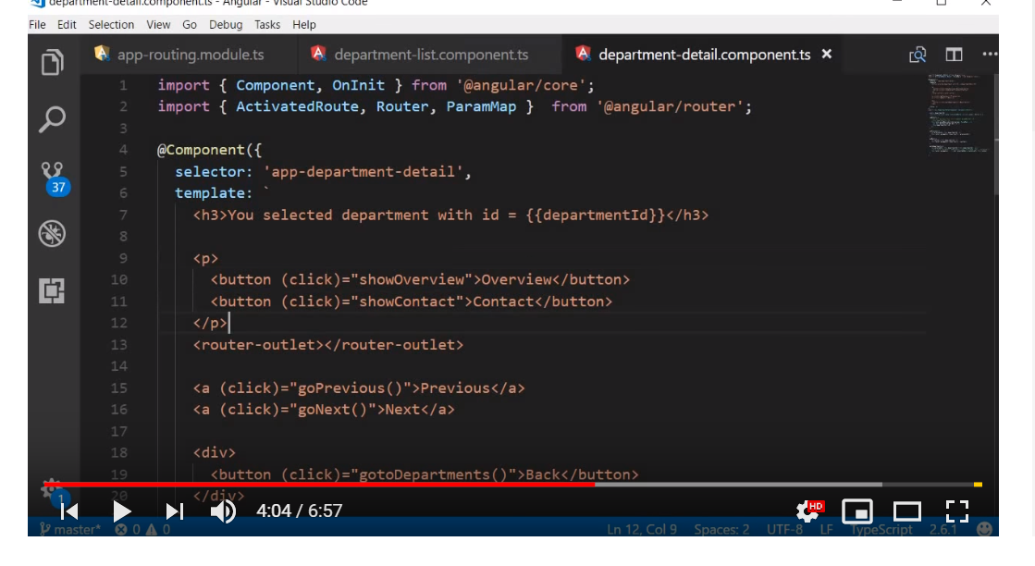

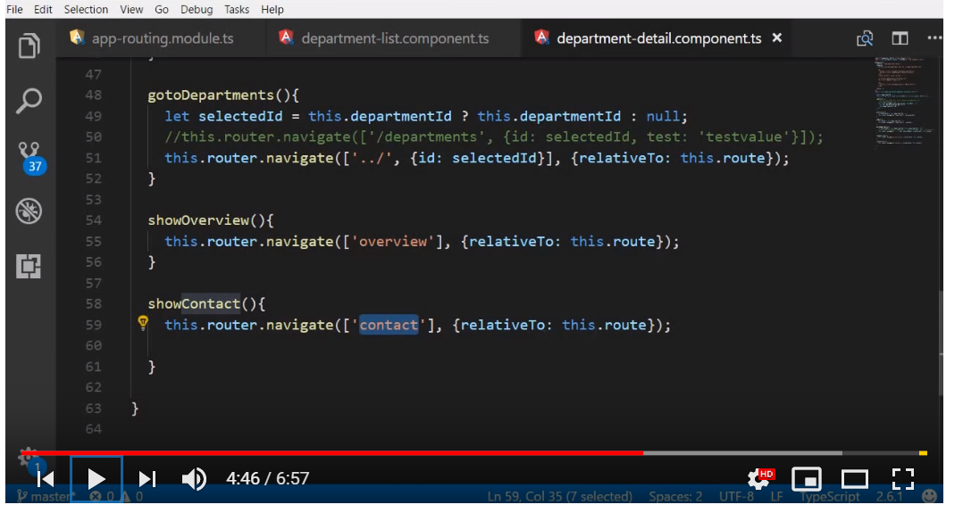

**Angular 6 new features and changes**

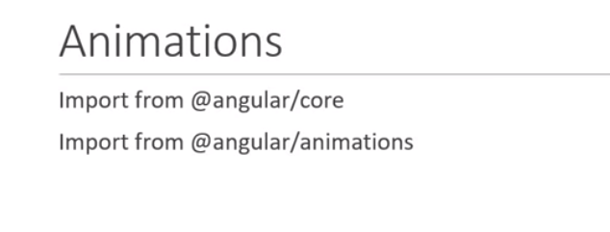

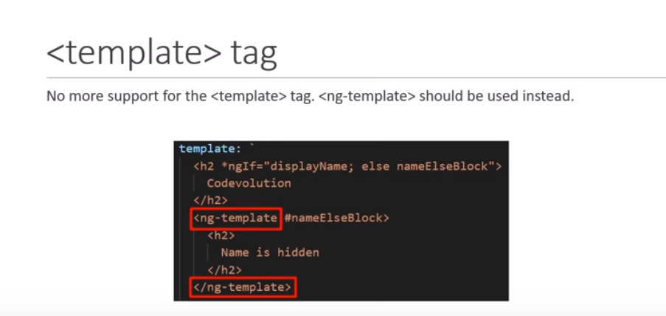

**Service will be available everywhere**

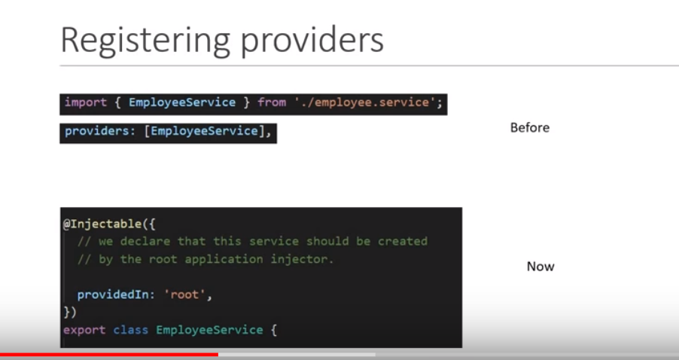

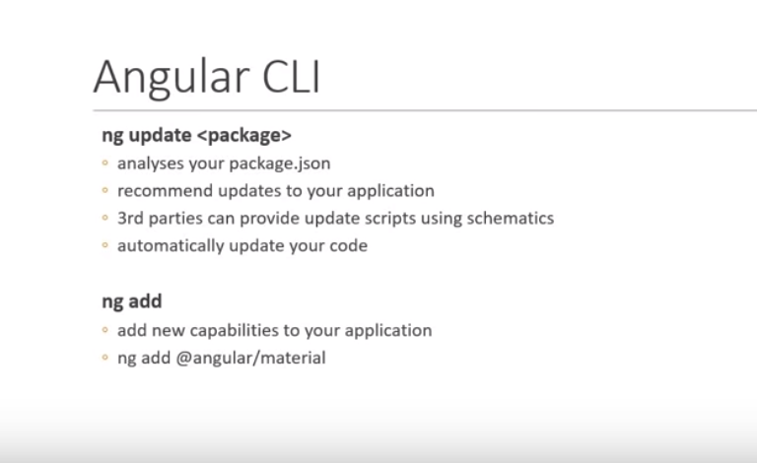

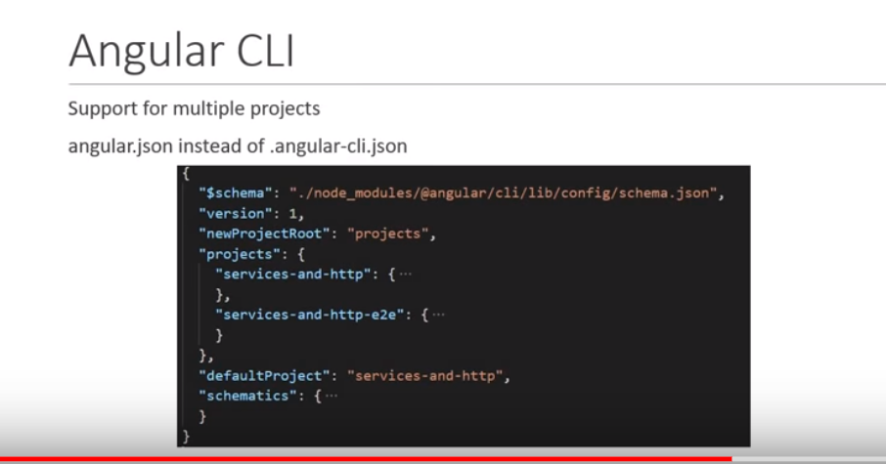

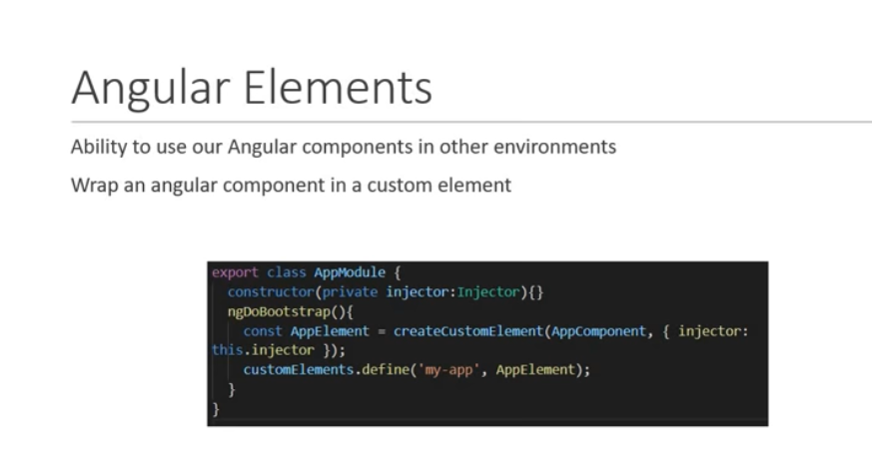

**Update.angular.io**